Pharmacy Reengineering (PRE)

Inbound ePrescribing (IEP)

VistA Patch # PSO*7.0*527

User Guide



August 2018

Version 2.3

Department of Veterans Affairs

Office of Information and Technology (OIT)

Revision History

| Date | Revision | Description | Author |
| --- | --- | --- | --- |
| 08/29/2018 | 2.3 | Incorporate customer comment to add a clarifying note below Table 2: VistA OP Inbound eRx Holding Queue User Roles and Responsibilities | Technatomy |
| 08/12/2018 | 2.2 | Technical Writer Review and 508 accessibility checks. | Technatomy |
| 07/28/2018 | 2.1 | Updated screenshots and added 30 day Lookback. | Technatomy |
| 04/12/2018 | 2.0 | Updated screenshots to include 2.1 changes. | A. Zenk |
| 11/15/2017 | 1.0 | Baseline release:  Updated Table of Figures.  Updates based on feedback from HPS.  Updated screenshots and verbiage throughout the document, formatting and sections Inbound ePrescribing Workflow and Summary Screen, Pharmacy Management section.  Updates made based on changes made during SureScripts Certification and IOC Production Testing. | Technatomy |

Table of Contents

Unit 1. Introduction to Inbound ePrescribing 1

Organization of the Inbound ePrescribing User Guide 1

Inbound ePrescribing Overview 1

Purpose 1

Overview 1

User Interfaces 4

Inbound ePrescribing Web-Based Application 4

VistA Outpatient Pharmacy eRx Holding Queue 4

Inbound ePrescribing Workflow 4

Inbound ePrescribing Architecture 6

Roles and Capabilities 8

Acronyms and Abbreviations 10

Unit 2. Inbound ePrescribing Web-Based Application 12

Inbound ePrescribing Web-Based Application Overview 12

Purpose 12

Access Requests 12

Accessing the Application 12

Screen Navigation and Description 14

Inbound eRx Homepage 15

Pharmacy Management 15

Track/Audit 16

Reports 16

User Management 17

Help Page 18

Inbound ePrescribing Web-based Application Capabilities 19

Pharmacy Management 19

Searching for a Pharmacy 19

Adding a Pharmacy 19

Updating a Pharmacy 19

Disable eRx 20

Temporarily Disable eRx 20

Enable eRx 22

Track/Audit 22

Searching for a Message 22

Export Search Results 26

Inbound/Outbound Message Detail 27

NewRx Message 27

Error Messages 28

Verify Messages 29

Status Messages 30

Reports 31

Export Reports 34

User Management 34

Add New User 35

Modify User Roles 37

Delete Users 37

Help Desk 37

Help Desk Ticket Instructions 37

Fax Failover 40

Unit 3. VistA Outpatient Pharmacy eRx Holding Queue 41

Purpose 41

Setting Up Default eRx Clinic (Optional) 41

Accessing the eRx Holding Queue 41

eRx Holding Queue List View 42

eRx Default Lookback Days 43

eRx Holding Queue Summary Screen 44

eRx Actions 46

Patient-Level Record Lock 47

Manual Validation 48

Validate Patient 49

Patient Auto-Match in the Processing Hub 49

Patient Manual Validation Screen Overview 50

Edit Patient 52

Accept Patient Validation 53

Automatic Patient Validation 54

Validate Provider 55

Provider Auto-Match in the Processing Hub 55

Provider Manual Validation Screen Overview 56

Edit Provider 56

Accept Provider Validation 57

Automatic Provider Validation 59

Validate Drug/SIG 60

Drug Auto-Match in the Processing Hub 60

Drug/SIG Manual Validation Screen Overview 61

Edit Drug/SIG 62

Additional Field-level Information: 64

Accept Drug/SIG Validation 65

Wait Status Flag ‘W’ 66

Accepting eRxs in the eRx Holding Queue 67

Rejecting eRxs in the eRx Holding Queue 69

Printing in the eRx Holding Queue 70

Placing eRxs on Hold in the eRx Holding Queue 72

Un Hold eRx in the eRx Holding Queue 74

Removing eRxs in the eRx Holding Queue 75

Searching and Sorting in the eRx Holding Queue 75

Searching eRxs 76

Search eRx – Patient Name 76

Search eRx – Date of Birth 78

Search eRx – Received Date Range 78

Search eRx – Provider Name 80

Search eRx – ERX Status 81

Search eRx – Drug Name 81

Sorting eRxs 82

Sort eRx – Patient Name 84

Sort eRx – Date of Birth 84

Sort eRx – Received Date Range 84

Sort eRx – Provider Name 85

Sort eRx – eRX Status 85

Sort eRx – Drug Name 85

Complete Orders from OERR and Patient Prescription Processing 86

Help Desk 89

Appendix A Holding Queue Status Codes & Descriptions 90

Appendix B NCPDP Error Codes 92

**List of Figures**

Figure 1‑1: Inbound ePrescribing Web-based Application 4

Figure 1‑2: Inbound ePrescribing Process Flow 5

Figure 1‑3: Inbound ePrescribing Architecture 7

Figure 2‑1: VA Single Sign-on 12

Figure 2‑2: Select a Certificate 13

Figure 2‑3: Active Client Login 13

Figure 2‑4: Warning Message 13

Figure 2‑5: Home Screen 14

Figure 2‑6: Web-Based Application Screen Layout 14

Figure 2‑7: Home Screen 15

Figure 2‑8: Pharmacy Management Screen 16

Figure 2‑9: Track/Audit Screen 16

Figure 2‑10: Reports Screen 17

Figure 2‑11: User Management Screen 17

Figure 2‑12: Help Screen 18

Figure 2‑13: Help Page 18

Figure 2‑14: Narrow Search by VISN 19

Figure 2‑15: NCPDP ID Column Hyperlinks 20

Figure 2‑16: Edit Pharmacy Screen 21

Figure 2‑17: Inbound Erx Enabled Drop Down 21

Figure 2‑18: Update Pharmacy Information 22

Figure 2‑19: Enable/Disable Pharmacy 22

Figure 2‑20: Track/Audit Search Criteria 23

Figure 2‑21: Track/Audit eRx Search 24

Figure 2‑22: Search Results 24

Figure 2‑23: Export Search Results 26

Figure 2‑24: Track/Audit Export Prompt (after clicking Export Buttons) 26

Figure 2‑25: Track/Audit Grid View 27

Figure 2‑26: eRx Reference # Hyperlink 27

Figure 2‑27: Track/Audit Detail Screen for NewRx Message Type 28

Figure 2‑28: NewRx Detail Screen: Available Actions 28

Figure 2‑29: Track/Audit Detail Screen for Error Message Type 29

Figure 2‑30: Track/Audit Detail Screen - Return to Search/Print Buttons 29

Figure 2‑31: Track/Audit Screen Criteria - Sent or Received Dropdown 30

Figure 2‑32: Track/Audit Detail Screen Status/Verify Message Type 30

Figure 2‑33: Track/Audit Detail Screen Status Message Type 31

Figure 2‑34: Summary Report Dropdown 31

Figure 2‑35: Reports Screen Filter Criteria – Select VISN from Dropdown 32

Figure 2‑36: Reports Screen Filter Criteria - Select Station ID from Dropdown 32

Figure 2‑37: Reports Screen Filter Criteria - Select Date Range 33

Figure 2‑38: Run Report Button 33

Figure 2‑39: Summary Report Results 33

Figure 2‑40: Export Report Buttons 34

Figure 2‑41: Summary Report Export Prompt (after clicking Export Button) 34

Figure 2‑42: Add User - User ID, First Name, Last Name 35

Figure 2‑43: Add User - Select User Roles 35

Figure 2‑44: Add User - Save and Cancel 36

Figure 2‑45: Select User Roles 37

Figure 2‑46: YourIT Desktop Icon 37

Figure 2‑47: Incident Section 38

Figure 2‑48: Create New 39

Figure 2‑49: New Incident 39

Figure 3‑1: Complete Orders from eRx Menu Option 42

Figure 3‑2: eRx Holding Queue List View 42

Figure 3‑3: eRx Holding Queue List View 43

Figure 3‑4: eRx Default Lookback Days 44

Figure 3‑5: Summary Screen Page 1 45

Figure 3‑6: Summary Screen Page 2 45

Figure 3‑7: Patient with No Known Allergies 46

Figure 3‑8: VistA Patient with Known Allergies 46

Figure 3‑9: Patient-Level Record Lock 47

Figure 3‑10: Summary Screen Actions 48

Figure 3‑11: Validate Patient 49

Figure 3‑12: Patient Validation Screen Display - Patient Not Validated/ Not Auto Matched 50

Figure 3‑13: Patient Validation Screen Display - Patient Not Validated / Patient Auto Matched 51

Figure 3‑14: VistA Patient with Known Allergies 51

Figure 3‑15: Patient Validated 52

Figure 3‑16: Edit Patient on a VistA Match 52

Figure 3‑17: Mismatch Warning Message 53

Figure 3‑18: Confirm Acceptance of Patient Validation 54

Figure 3‑19: Patient Validation Complete: Summary Screen Indicator 54

Figure 3‑20: Automatic Patient Validation 55

Figure 3‑21: Apply Patient Validation to Other eRxs 55

Figure 3‑22: Summary Screen Action - Validate Provider 55

Figure 3‑23: Provider Not Auto Matched / Not Validated 56

Figure 3‑24: Modify Current VistA Provider 57

Figure 3‑25: Select Provider Warning Message 57

Figure 3‑26: Before Provider Validation (Validate Provider Screen) 58

Figure 3‑27: After Provider Validation (Validate Provider Screen) 58

Figure 3‑28: After Provider Validation (Summary Screen) 59

Figure 3‑29: Automatic Provider Validation 59

Figure 3‑30: Validate Drug / SIG 60

Figure 3‑31: Drug Validation Screen Display - VistA Drug Not Validated / Not Auto Matched 61

Figure 3‑32: Drug Validation Screen Display - VistA Drug Matched / Not Validated 62

Figure 3‑33: eRx Display During Edit Drug / SIG 63

Figure 3‑34: Confirm Acceptance of Drug / SIG Validation 65

Figure 3‑35: Drug / SIG Validation Complete (Validate Drug / SIG Screen) 65

Figure 3‑36: Drug / SIG Validation Complete (Summary Screen) 66

Figure 3‑37: eRx Holding Queue Summary Screen with Validations Complete 67

Figure 3‑38: eRx Holding Queue List View with eRx Record in ‘W’ Status 67

Figure 3‑39: Accept eRx - Sample Validation Errors 68

Figure 3‑40: Accept eRxs 68

Figure 3‑41: eRxs Sent to Pending Outpatient Orders 68

Figure 3‑42: Rejecting an eRx 69

Figure 3‑43: Reject Message in Processing Hub 70

Figure 3‑44: Print Display of eRx 71

Figure 3‑45: Hold eRx 73

Figure 3‑46: Select Hold Reason Code 73

Figure 3‑47: Hold Status and Reason 73

Figure 3‑48: Hold Status in Status Column 74

Figure 3‑49: Un Hold eRx 74

Figure 3‑50: Removing an eRx 75

Figure 3‑51: Search Queue Actions 76

Figure 3‑52: Search Criteria - Patient Name 77

Figure 3‑53: Patient Name Search 77

Figure 3‑54: Search eRx by Patient Name Results 77

Figure 3‑55: Search Criteria - Date of Birth 78

Figure 3‑56: Search eRx by Date of Birth Results 78

Figure 3‑57: Search Criteria - Received Date Range 79

Figure 3‑58: Enter Beginning and Ending Date 79

Figure 3‑59: Search eRx by Received Date Range 79

Figure 3‑60: Search Criteria - Provider Name 80

Figure 3‑61: Enter Provider Name 80

Figure 3‑62: Search eRx by Provider 80

Figure 3‑63: Search Criteria - eRx Status 81

Figure 3‑64: Search by eRx Status 81

Figure 3‑65: Search Criteria - Drug Name 82

Figure 3‑66: Search eRx by Drug Name 82

Figure 3‑67: Sort Entries Action 83

Figure 3‑68: Sort by Patient Name 84

Figure 3‑69: Sort by Received Date Range 85

Figure 3‑70: Sort Criteria - Sort by Provider 85

Figure 3‑71: Hidden Option EP / Print Display of eRx 86

Figure 3‑72: eRx Display in Pending Queue - Page 1 87

Figure 3‑73: eRx Order in Pending Queue – Page 2 88

Figure 3‑74: eRx Order in Pending Queue - Page 3 88

Figure 3‑75: eRx Order in Pending Queue - Page 4 88

Figure 3‑76: eRx Order in Pending Queue - Page 5 89

List of Tables

Table 1: Inbound ePrescribing Web-Based Application User Roles & Capabilities 8

Table 2: VistA OP Inbound eRx Holding Queue User Roles & Capabilities 8

Table 3: Acronyms and Abbreviations 10

Table 4: Track/Audit Search Criteria Descriptions 23

Table 5: Search Results Fields & Descriptions 25

Table 6: Summary Report Columns 33

Table 7: Holding Queue Status Codes & Descriptions 90

Table 8: NCPDP Error Codes 92

# Introduction to Inbound ePrescribing

This unit provides the purpose and organization of the Pharmacy Reengineering (PRE) Inbound ePrescribing (IEP) solution and a list of acronyms and abbreviations.

## Organization of the Inbound ePrescribing User Guide

The PRE IEP user guide is comprised of the following three sections:

* Unit 1 – Introduction to Inbound ePrescribing: Discusses general PRE Inbound ePrescribing information. Also included is a list of acronyms and abbreviations.
* Unit 2 – Inbound ePrescribing Web-Based Application: Outlines the IEP Web-based application and capabilities, including Pharmacy Management, Track/Audit, Reports, and User Management functions.
* Unit 3 – VistA Outpatient Pharmacy eRx Holding Queue: Discusses the VistA OP eRx Holding Queue and capabilities, including eRx validation, search, sort, hold, acceptance, remove, and rejection.

## Inbound ePrescribing Overview

The PRE IEP functionality addresses a longstanding need for the Department of Veterans Affairs (VA) to be able to receive and process prescriptions from external providers. This enhancement moves the VA towards increased efficiency and improved customer satisfaction.

### Purpose

The purpose of PRE IEP is to enable VA to receive and subsequently process electronic prescriptions (eRxs) from outside of VA. This user guide serves as a guide and useful reference for VA Pharmacy Users, Systems Administrators, Managers, and other VA staff to assist in accessing, navigating, and performing tasks associated with the PRE IEP Web-based application and the Veterans Health Information Systems and Technology Architecture (VistA) Outpatient Pharmacy (OP) eRx Holding Queue.

### Overview

To improve on its ability to deliver Veterans their medications as quickly and efficiently as possible, the Veterans Health Administration (VHA), Patient Care Services (PCS), and Pharmacy Benefits Management (PBM) requested a new capability as part of the PRE program to receive inbound eRxs from an external provider (e.g., a doctor not associated with the VA, medical staff at a Department of Defense (DoD) military treatment facility, etc.).

Overall, PRE IEP provides:

* Improved efficiency. More efficient use of VA pharmacy resources and non-VA provider resources based on:
  + Fewer transcribing/translation errors.
  + Clear/error-free communications.
  + Time saved not having to communicate back and forth regarding the content of a prescription.
* Improved Veteran/beneficiary satisfaction. Makes the existing manual processing easier, more efficient, and more effective through the automation of the prescription process by:
  + Reducing the risk of loss of paper Rxs.
  + Enabling more secure communication of Rx data.
  + Providing timelier dispensing of Rxs prescribed by non-VA providers.
* Improved patient safety: Reduces transcription errors.
* Improved data accuracy: Provides enhanced functionality within VistA OP that improves the accuracy and use of the data it collects.

By automating data transmission from providers to the VA, and between other pharmacies, the need for VA pharmacy personnel to manually input Rx data from non-VA providers is largely eliminated, reducing the chance for data to be entered incorrectly or missed.

Specific elements of what is included in PRE IEP include:

* Receiving and processing inbound eRxs, where “inbound” refers to the ordering of medication or medical related supplies for a VA patient by a non-VA provider; to be filled at a VA pharmacy.
* Pharmacy Service is not responsible for filling prescriptions for non-expendable medical equipment.
* Pharmacy Service may dispense refills for expendable supplies upon receipt of requests from patients with continuing eligibility for a period not to exceed one year from the date of the last signed order.
* Expendable stock items may include: catheters, colostomy sets, ileostomy sets and/or supplies, plastic and rubber gloves, skin preparations and powders, urinal bags and drainage supplies, incontinence supplies, etc.
* Electronically receiving and processing outpatient prescriptions only, including prescriptions created for a VA patient upon discharge from a non-VA hospital to be filled on an outpatient basis by a VA pharmacy.
* Receiving and processing inbound eRxs from non-VA providers that currently prescribe medications and medical-related supplies for Civilian Health and Medical Program of the VA (CHAMPVA) beneficiaries and which are currently handled by the Meds by Mail (MbM) program.
* Sending outbound electronic notifications from a VA pharmacy that received an inbound eRx, to the non-VA provider that originally sent the eRx.

The following areas are not included in PRE IEP:

* VA providers generating eRxs at one VA Medical Center (VAMC) location to be electronically transmitted to and processed by (filled, dispensed, etc.) a different VAMC location’s pharmacy.
* Initiating outbound eRxs (generation of an eRx by a VA provider to be filled at a non-VA pharmacy).
* Electronic receipt and processing of any VA or non-VA inpatient medication orders.
* Electronic receipt and processing of any VA or non-VA orders for Durable Medical Equipment (DME), such as wheel chairs.
* Electronic receipt and processing of Rx refill requests from a VA patient’s non-VA Electronic Health Record (EHR) system.
* Electronic transfers of prescriptions from any non-VA pharmacy to a VA pharmacy.
* Electronic transfers of prescriptions from a VA pharmacy to a non-VA pharmacy.
* The ability for the VA to request an Electronic Prior Authorization (ePA) form and authorization from a provider.

The following are out of an eRx user’s control, which requires validation by Pharmacists.

* Patient: eRxs can be sent for any patient, including Veterans or non-Veterans.
* Provider: eRxs can be sent by any provider, whether VA authorized or not.
* Drugs: VA has no control over the drug, nor the name of drug sent to VA.
* SIG: VA has no control over directions that are sent to VA.
* All information coming to the VA is controlled by the EHR system which is what the provider is using to send information to the VA. VA has no control over the process.

### User Interfaces

There are two user interfaces associated with IEP, including the following:

* IEP Web-Based Application
* VistA Outpatient Pharmacy Module eRx Holding Queue

#### Inbound ePrescribing Web-Based Application

The IEP Web-based application is used by Pharmacy Users, Administrators, Pharmacy Managers, and PBM Admin personnel. It has tab displays for the following:

* Home
* Pharmacy Management
* Track/Audit
* Reports
* User Management
* Help

Figure 1‑1: Inbound ePrescribing Web-based Application

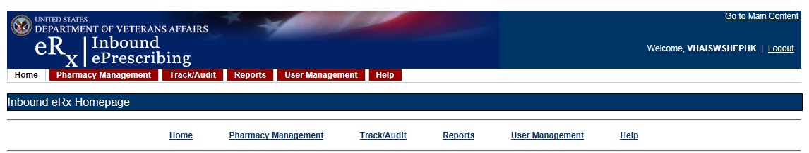

The IEP Web-based application is discussed in more detail in Unit 2 - Inbound ePrescribing Web-Based Application.

#### VistA Outpatient Pharmacy eRx Holding Queue

The VistA OP eRx Holding Queue display screens include new VistA screens that are used by VA Pharmacists and Technicians to validate and process eRxs.

The eRx Holding Queue is discussed in more detail in Unit 3 - VistA Outpatient Pharmacy eRx Holding Queue.

### Inbound ePrescribing Workflow

The IEP workflow is illustrated in the figure and described below.

Figure 1‑2: Inbound ePrescribing Process Flow



1. eRxs are sent from an external provider to SureScripts and/or Change Healthcare (CH). CH provides commercial ePrescribing solutions, and for the purposes of the IEP implementation, serves as a gateway to all participating ePrescribing providers nationwide.
2. CH verifies and transmits eRx transactions to/from SureScripts and/or an external provider’s EHR system and the IEP system.
3. The eRxs are routed from CH to the IEP Processing Hub via the Data Access Service (DAS) external gateway. DAS and CH communicate using https requests over a secured network.
4. In the IEP Processing Hub, auto checks occur on the eRxs for Patient, Provider, and Drug/SIG. The Master Veteran Index (MVI) is used for patient checking, depending on the data set that is sent by the Prescriber for that patient. For patient enrollment and eligibility checks, the Enrollment System (ES) is utilized. The ES assists Veterans to enroll for VA healthcare benefits and is the core application that feeds other VA systems with Enrollment and Eligibility (E&E) data. Patient Registration is also confirmed against the instance of the receiving pharmacy.
5. The Drug Name is matched against the local Drug File first, the VA Product Name next and then the National Drug Code (NDC), depending on which it matches first on. As a note, auto checks can be incorrect therefore the data must also be validated against the original eRx data sent (Please refer to the Validate Drug/SIG section).
6. The IEP Web-based GUI allows users to view and generate reports on the auto check results in the Processing Hub, as well as manage VA pharmacy information, and search for and print an eRx.
7. Once the eRx has completed all auto checks in the IEP Processing Hub, the original prescription, as well as the outcomes of all of the auto checks (patient, provider, and drug), are transmitted to VistA OP. VistA Link is used for the provider and drug checks against the VistA OP system.
8. The VistA OP’s IEP Holding Queue allows for the initial validation and acceptance of an eRx before being transmitted to Pending Outpatient Orders file for additional order checks and then final dispensing.

## Inbound ePrescribing Architecture

The IEP architecture is illustrated in the below figure, which depicts the different programs/applications that IEP interfaces with.

Figure 1‑3: Inbound ePrescribing Architecture

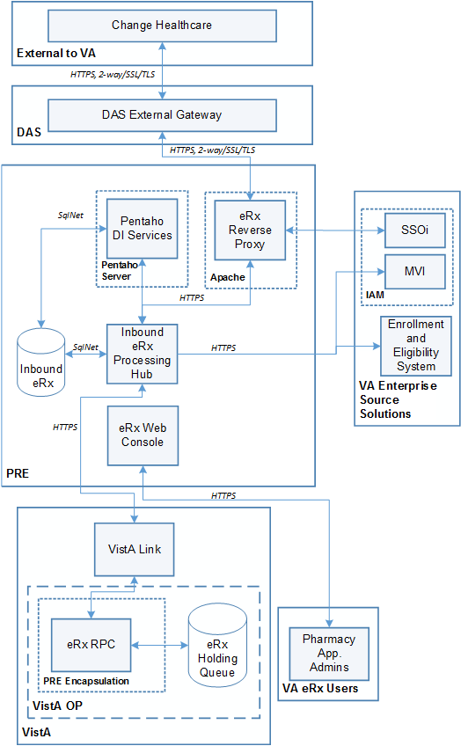

## Roles and Capabilities

IEP roles and tasks are described in this section as primary and secondary users. Primary users include VA Pharmacy Users. Secondary users include System Administrators, VA Pharmacy Managers, VA PBM personnel, Non-VA Providers, and External Pharmacy personnel. The following sections provide an overview of primary and secondary user roles and their capabilities within IEP.

VA users have the capability of performing eRx-related tasks in the IEP Web-based application and in the VistA OP eRx Holding Queue module. Specific tasks for each component are described in more detail in Unit 2 Inbound ePrescribing Web-Based Application and Unit 3 VistA Outpatient Pharmacy eRx Holding Queue.

The primary users of IEP are VA Pharmacy Users. Secondary user roles of this functionality include:

* Administrator – VA Local and National System Administrators
* Pharmacy Manager – VA Pharmacy Management to include VA management, hospital director, under sec, etc., or anyone outside pharmacy that will need to know how many and what is the cost of the project
* PBM Admin – All VA PBM personnel, including management
* Non-VA Providers – Submit inbound requests to VA and review statuses sent from VA

Details of the roles and capabilities for each user in the IEP Web-based application and the VistA eRx Holding Queue are outlined in the tables below.

Table 1: Inbound ePrescribing Web-Based Application User Roles & Capabilities

| User Role | Functionality |
| --- | --- |
| Administrator | Full Control, access to all tabs |
| Pharmacy Management | Home Pharmacy Management Track/Audit Reports Help |
| PBM Administrator | Home Pharmacy Management Track/Audit Reports Help |
| Pharmacy Users | HomeTrack/AuditReportsHelp |
| Default VA User (Read Only) | Home Reports Help |

Table 2: VistA OP Inbound eRx Holding Queue User Roles & Capabilities

| VistA Security Key | PSDRPH | PSO ERX ADV TECH | PSO ERX TECH | PSO ERX VIEW |
| --- | --- | --- | --- | --- |
| Validate Patient | X | X | X |  |
| Validate Provider | X | X | X |  |
| Validate Drug/SIG | X | X | X |  |
| Accept Validation | X | X |  |  |
| Accept eRx | X |  |  |  |
| Reject | X | X |  |  |
| Remove | X | X |  |  |
| Hold | X | X | X |  |
| Un Hold | X | X | X |  |
| Search/Sort | X | X | X | X |
| Print | X | X | X | X |

**NOTE:** When a user is assigned more than one VistA security key, the key with least access overrides the other keys assigned. For example, when a user is granted both PSDRPH and PSO ERX VIEW keys, access will drop to the level of the least access offered by PSO ERX VIEW key and the broader access of PSDRPH will be ignored.

## Acronyms and Abbreviations

The table below defines the acronyms referenced in this document.

Table 3: Acronyms and Abbreviations

| Term | Description |
| --- | --- |
| AITC | Austin Information Technology Center |
| CH | Change Healthcare |
| CHAMPVA | Civilian Health and Medical Program of the VA |
| CPRS | Computerized Patient Record System |
| CSV | Comma-separated value |
| DAS | Data Access Service |
| DEA | Drug Enforcement Administration |
| DME | Durable Medical Equipment |
| DOB | Date of Birth |
| DoD | Department of Defense |
| E&E | Enrollment & Eligibility |
| EHR | Electronic Health Record |
| ES | Enrollment System |
| HIN | Holder Identification Number |
| ePA | Electronic Prior Authorization |
| eRx | ePrescription |
| FQDN | Fully Qualified Domain Name |
| IEP | Inbound ePrescribing |
| MbM | Meds by Mail |
| MVI | Master Veteran Index |
| NAIC | North American Industry Classification |
| NAICS | North American Industry Classification System |
| NCPDP | National Council for Prescription Drug Programs |
| NDC | National Drug Code |
| NPI | National Provider Identifier |
| NSD | National Service Desk |
| OI&T | Office of Information & Technology |
| OP | Outpatient Pharmacy |
| PBM | Pharmacy Benefits Management |
| PCS | Patient Care Services |
| PIN | Personal Identification Number |
| POC | Point of Contact |
| PPO | Program Planning Oversight |
| PRE | Pharmacy Reengineering |
| PHI | Protected Health Information |
| PHR | Personal Health Record |
| PII | Personally Identifiable Information |
| PIV | Personal Identification Verification |
| PRE | Pharmacy Reengineering |
| SSN | Social Security Number |
| Tech | Technician |
| UI | User Interface |
| UPN | Universal Product Number |
| UPC | Universal Product Code |
| VA | Department of Veterans Affairs |
| VAMC | VA Medical Center |
| VDL | VA Documentation Library |
| VHA | Veterans Health Administration |
| VISN | Veterans Integrated Service Network |
| VistA | Veterans Health Information Systems and Technology Architecture |

# Inbound ePrescribing Web-Based Application

## Inbound ePrescribing Web-Based Application Overview

### Purpose

The Inbound ePrescribing (IEP) Web-based application provides eRx management, administration, and monitoring capabilities.

### Access Requests

Please contact the supervisor or the administrator assigned at your local site for managing the application for questions on access to the IEP Web-based application and/or modifications to user roles/permissions.

### Accessing the Application

A Personal Identification Verification (PIV) card is required to access the application, using the following steps:

1. On the VA Single Sign-on screen, select the **Sign In with VA PIV Card** icon.

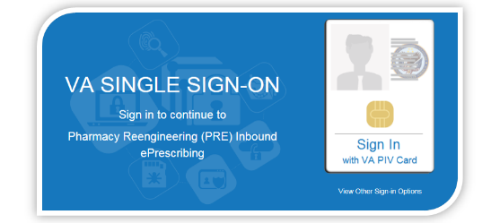

Figure 2‑1: VA Single Sign-on

1. In the “Select a Certificate” dialog, select the desired certificate and then select **OK**.

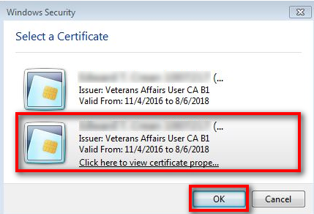

Figure 2‑2: Select a Certificate

1. In the “ActivClient Login” dialog, enter the Personal Identification Number (PIN) in the “PIN” text box and select **OK**.

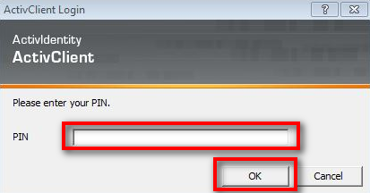

Figure 2‑3: Active Client Login

1. A warning message displays. Select Accept.

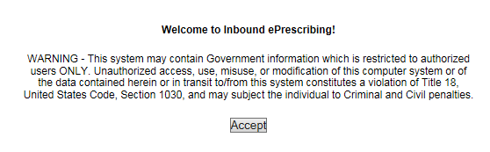

Figure 2‑4: Warning Message

When authentication and authorization is successful, the application home screen displays.

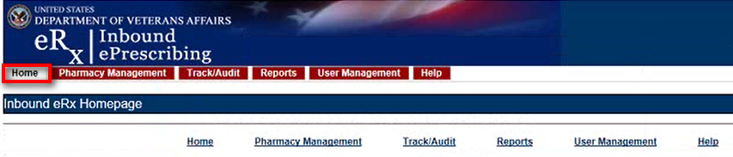

Figure 2‑5: Home Screen

### Screen Navigation and Description

The following figure outlines the key areas of the screen layout. Brief descriptions of the screen layout are provided below:

1. The logged-in user’s VA User ID and logout link displays on the right side of the banner.
2. Below the banner, the main tabs display for accessing the screens within the application.
3. The name of the screen displays below the main tabs.
4. The bottom of the screen also contains links to the main tabs.
5. On the top-right of the screen is a **Go to Main Content** link for Section 508 purposes to allow a user to be directed to the main content on the screen.

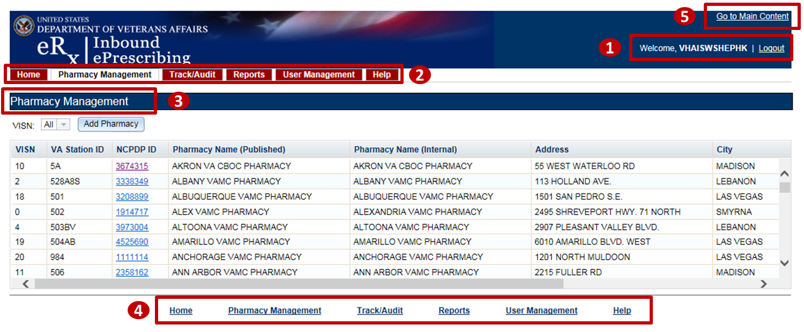

Figure 2‑6: Web-Based Application Screen Layout

Only the menu bar tabs that the user has access to display. Access to the tab displays or screens is granted or restricted by roles assigned to the user by the administrator; refer to the Roles and Capabilities section. There are links to the tabs on the bottom of each page as well.

The tabs are:

* **Home**/Inbound eRx Homepage – All Users
* **Pharmacy Management** – Administrators, Pharmacy Managers, and PBM Admin
* **Track/Audit** – Administrators, Pharmacy Managers, PBM Admin, and VA Pharmacy Users
* **Reports** – All Users
* **User Management** – Administrators
* **Help** – All Users

#### Inbound eRx Homepage

The Inbound eRx Homepage is displayed when successful login authentication and verification is completed. The Inbound eRx Homepage is always accessible by selecting the **Home** tab in the menu bar. The Home screen is accessible to all user roles. However, only the tabs authorized for the user’s role are displayed.



Figure 2‑7: Home Screen

#### Pharmacy Management

To access the Pharmacy Management screen, select the **Pharmacy Management** tab in the menu bar. The Pharmacy Management screen displays the Pharmacy Management table that provides information about pharmacies and allows Administrators and Pharmacy Managers to search for, add, and edit pharmacies. Users can also enable/disable receiving prescriptions targeted for a particular pharmacy Inbound eRx delivery. The default view displays all VA pharmacies. Refer to the Pharmacy Management section of this manual for more information.

Figure 2‑8: Pharmacy Management Screen

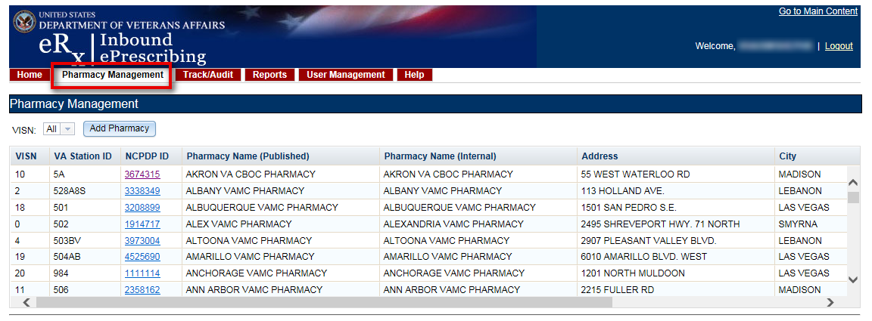

#### Track/Audit

To access the Track/Audit eRx screen, select the **Track/Audit** tab in the menu bar. The Track/Audit eRx screen displays allow users to track and view an audit trail of eRxs.

Figure 2‑9: Track/Audit Screen

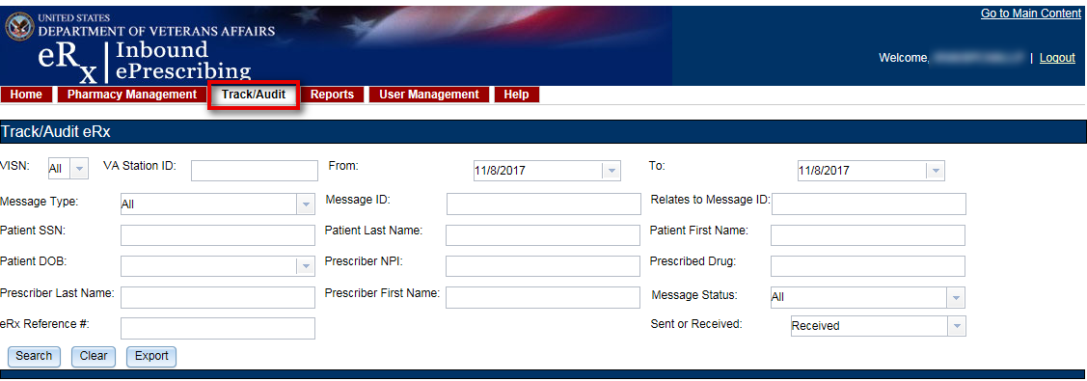

#### Reports

To access the Reports screen, select the **Reports** tab in the menu bar. The Reports screen provides all users with the ability to run and view a Summary Report.

The system uses the comma-separated value (.CSV) format. Users can view reports using a third-party tool, such as Microsoft Excel.

Figure 2‑10: Reports Screen

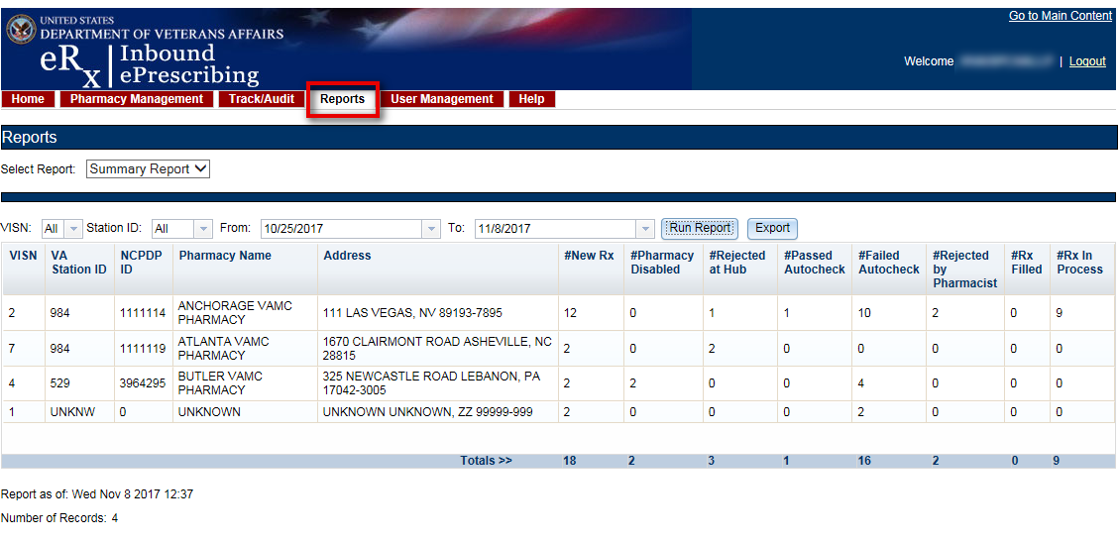

#### User Management

To access the User Management screen, select the **User Management** tab in the menu bar. The User Management screen provides Administrators with the ability to add and delete users and modify user roles. This screen only displays for users with Administrator access.

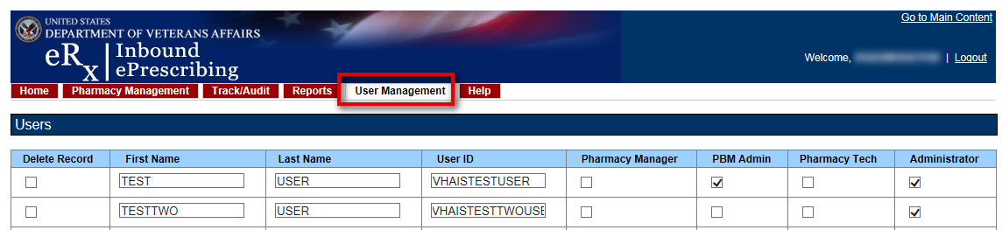

Figure 2‑11: User Management Screen

#### Help Page

To access the Help page, select the **Help** tab in the menu bar. The Help page provides help topics and production support information.



Figure 2‑12: Help Screen

When the **Help** tab is selected, the Help Page displays in a new window.

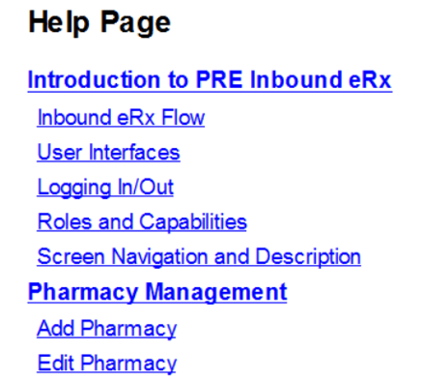

Figure 2‑13: Help Page

## Inbound ePrescribing Web-based Application Capabilities

The following sections provide descriptions of the IEP Web-based application’s capabilities within each tab.

### Pharmacy Management

The Pharmacy Management screen displays the Pharmacy Management table. The default view displays all VA pharmacies. Actions available to users include:

* Searching for a Pharmacy
* Adding a Pharmacy
* Updating a Pharmacy

#### Searching for a Pharmacy

Users can search for a pharmacy from the Pharmacy Management screen. The default view lists all VA pharmacies.

To search for a pharmacy:

1. Select the desired VISN number from the “VISN” drop down.
2. Select the desired Station ID from the “Station ID “drop down. \
3. Select **Search**.

The Pharmacy Management table for the selected VISN displays.

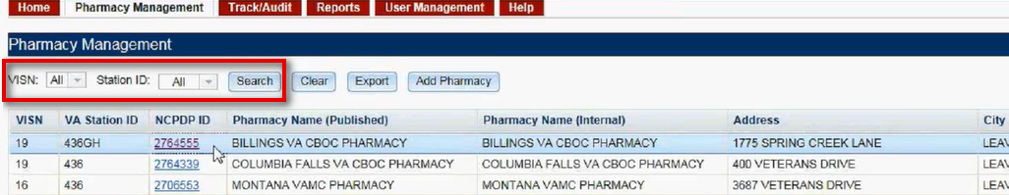

Figure 2‑14: Narrow Search by VISN

#### Adding a Pharmacy

To add a new pharmacy, please submit a help desk ticket to the VA National Service Desk (NSD) at 855-NSD-HELP (673-4357) and reference “Inbound eRx”.

**NOTE:** The pharmacy must be pre-registered as a pharmacy in ePharmacy. ePharmacy is supported by CH therefore ePharmacy registration adds the pharmacy to the same CH Pharmacy Directory (*NCPDP ID is required) utilized by Inbound eRx. For IEP, CH must also enable eRx support for the pharmacy in their Directory. Also, the pharmacy must be “registered” with IEP by adding the pharmacy through the IEP Web-based application.

#### Updating a Pharmacy

To update information for a VA pharmacy, please submit a help desk ticket to the VA National Service Desk (NSD) at 855-NSD-HELP (673-4357) and reference “Inbound eRx”.

##### Disable eRx

To completely halt a specific Pharmacy from receiving ePrescriptions, please submit a help desk ticket to the VA National Service Desk (NSD) at 855-NSD-HELP (673-4357) and reference “Inbound eRx”.

**NOTE:** If a pharmacy is to be disabled for a long duration, a request must be made to CH. Note that the NSD will route the ticket to an IEP administrator to assist with this step. CH can switch the pharmacy to fax only or turn off eRx delivery (electronic or fax) completely.

###### Temporarily Disable eRx

In case where a site needs to halt receiving ePrescriptions temporarily, use Disable eRx/Enable eRx fields. Disabling a pharmacy allows users the ability to temporarily disable the pharmacy from receiving eRxs in the event of a natural or facility disaster, maintenance, or move. This disables the pharmacy from receiving New eRxs, but outbound messages still go back to the external provider via CH. The pharmacy is disabled on the Processing Hub but no changes are made in CH.

**NOTE:** The enable/disable in the Processing Hub is for a temporary disable, which will also allow outgoing messages (rejection messages for any new eRxs still in process) to continue flowing from VistA. Additionally, incoming messages will still flow from CH to the Processing Hub for the pharmacy, however an error message will be returned to the provider saying that Inbound eRx messaging is currently not available. In these cases, CH will then send a fax of the eRx to the pharmacy.

To temporarily disable a pharmacy:

1. From the Pharmacy Management screen, select the hyperlink for the desired pharmacy to edit in the “NCPDP ID” column.

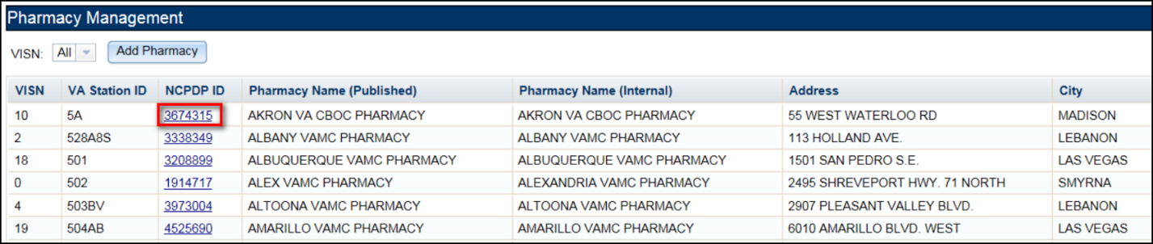

Figure 2‑15: NCPDP ID Column Hyperlinks

The Edit Pharmacy screen displays.

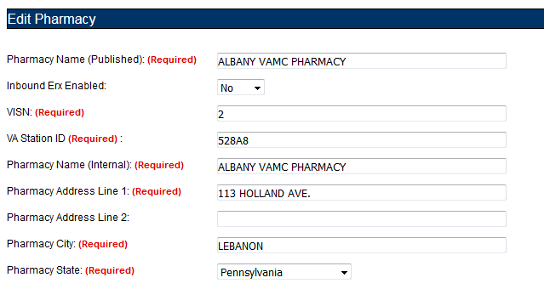

Figure 2‑16: Edit Pharmacy Screen

1. Select **No** from the “Inbound Erx Enabled” drop down.

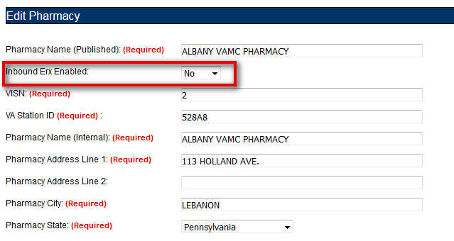

Figure 2‑17: Inbound Erx Enabled Drop Down

1. At the bottom of the Edit Pharmacy screen, select **Update** to save all changes. The date that the fields were modified displays in the “Updated Date” field.

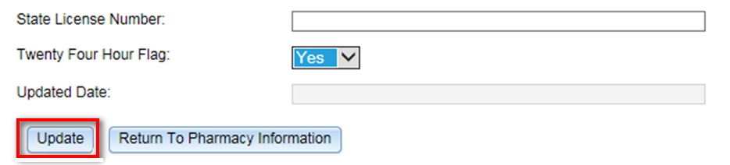

Figure 2‑18: Update Pharmacy Information

Selecting the **Return to Pharmacy Information** button returns the user to the Pharmacy Management screen.

##### Enable eRx

The pharmacy can be enabled once it is ready to receive eRxs again. To enable a pharmacy select **Yes** from the “Inbound Erx Enabled” drop down on the Edit Pharmacy screen and select the **Update** button.

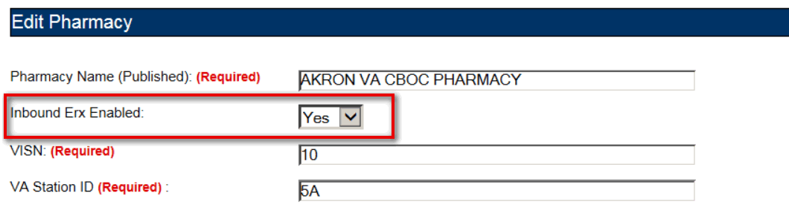

Figure 2‑19: Enable/Disable Pharmacy

**NOTE:** If a pharmacy is not enabled and a prescription comes in for that pharmacy, an error message is sent back to the provider’s EHR system to notify the provider that the pharmacy is not currently receiving eRxs.

### Track/Audit

The Track/Audit screen allows users to search and track prescriptions and provides the ability to view and print the details of a prescription.

#### Searching for a Message

To search for a message:

1. Select the desired search criteria from the drop downs and enter search keywords in the text fields.

Figure 2‑20: Track/Audit Search Criteria

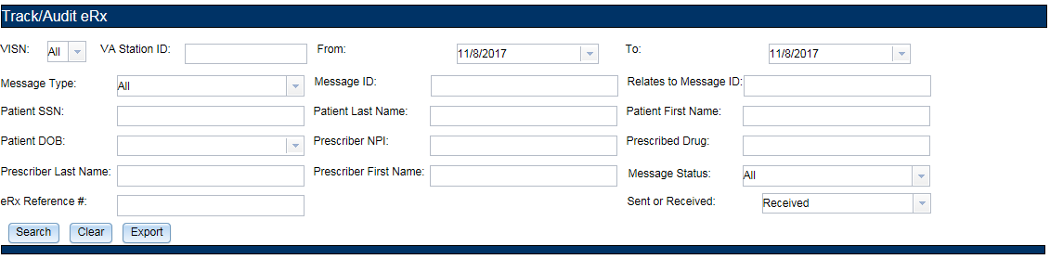

The search criteria are listed in the table below.

Table 4: Track/Audit Search Criteria Descriptions

| Search Field | Field Type | Description | Drop Down Options |
| --- | --- | --- | --- |
| VISN | Drop Down | VISN number that a VA pharmacy is associated with | All VISNs, each VISN number |
| Station ID | Text | Station ID of the VA pharmacy | N/A |
| From | Text or Calendar Drop Down | Beginning date. Choose the From date for the date range search, select date from calendar or type date | N/A |
| To | Text or Calendar Drop Down | End date. Choose the To date for a date range search; select the date from the calendar or enter a date in MM/DD/YYYY format | N/A |
| Message Type | Drop Down | Type of NCPDP message | All, NewRx, Status, Error, Verify |
| Message ID | Text | Prescription message ID (generated by Change Healthcare for incoming eRxs) | N/A |
| Relates to Message ID | Text | To search for messages related to a Message ID | N/A |
| Patient SSN | Text | Patient Social Security Number | N/A |
| Patient Last Name | Text | Patient last name | N/A |
| Patient First Name | Text | Patient first name | N/A |
| Patient DOB | Drop Down | Patient date of birth | Calendar |
| Prescriber NPI | Text | Prescriber National Provider Identifier (NPI) | N/A |
| Prescribed Drug | Text | Drug prescribed from the eRx | N/A |
| Prescriber First Name | Text | First name of prescriber | N/A |
| Prescriber Last Name | Text | Last name of prescriber | N/A |
| Message Status | Drop Down | Processing Hub message status | Auto check Processing Completed, VistA OP Delivery Successful, VistA OP Delivery Retries Exceeded, Auto check in Progress, Pharmacy Inbound eRx Not Enabled, Pharmacy Unknown |
| eRx Reference # | Text | Unique, internal VA reference # assigned to all messages | N/A |
| Sent or Received | Drop Down | Select Sent (Outbound) or Received (Inbound) messages | Received, Sent |

1. Select **Search** to execute the search.

Figure 2‑21: Track/Audit eRx Search

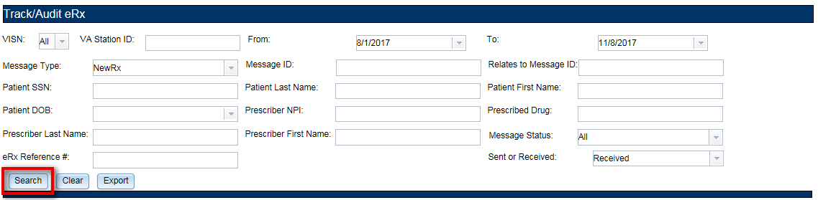

The search results display in the table. The total number of records in the search results display at the bottom of the table.

Figure 2‑22: Search Results

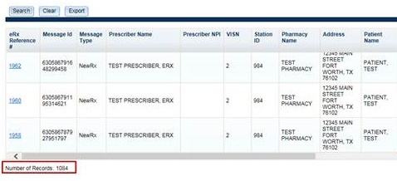

The Search Results fields and descriptions are listed in the table below.

Table 5: Search Results Fields & Descriptions

| Field | Description |
| --- | --- |
| eRx Reference # | Unique, internal VA reference # assigned to all messages |
| Message Id | Message identification number |
| Message Type | The type of message. Message types include: New eRx, Error, Verify, and Status. |
| Prescriber Name | First and last name of the prescriber |
| Prescriber NPI | National Provider Identifier for the prescriber |
| VISN | VISN that the VA pharmacy is associated with |
| Station ID | Station ID of the VA pharmacy |
| Pharmacy Name | Internal VA pharmacy name |
| Address | Address of VA pharmacy |
| Patient Name | First and last name of the patient |
| Patient DOB | Date of birth for the patient |
| Patient SSN | Social security number of the patient |
| Drug Prescribed | Drug prescribed to the patient |
| Relates to Message ID | Lists messages related to a particular Message ID |
| Received Date | Date that the eRx was received by VA |
| Patient Auto Check Status | Results of system patient auto-validation check |
| Provider Auto Check Status | Results of system provider auto-validation check |
| Drug Auto Check Status | Results of system drug auto-validation check |
| Message Status | Current status of the message |

#### Export Search Results

From the Track/Audit tab, users have the capability of exporting the search results. Exports are in .CSV format and can be viewed in Microsoft Excel.

To export the search results:

1. Select the **Export** button.

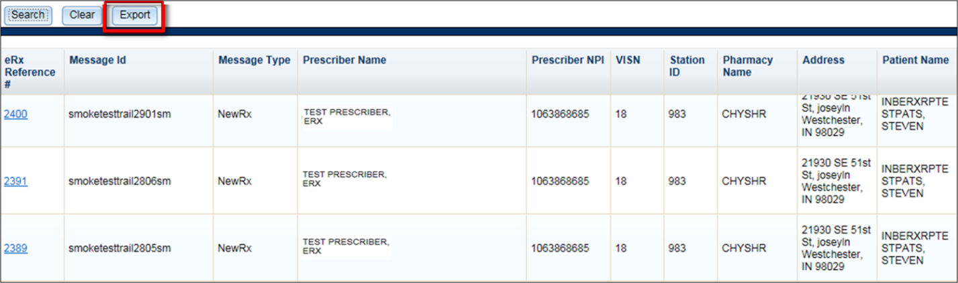

Figure 2‑23: Export Search Results

A prompt displays asking to Open or Save the results.

1. Select Open to view the results.
2. To save the results, select Save. The system displays a Save As dialog. Navigate to a location on your system to save the file.



Figure 2‑24: Track/Audit Export Prompt (after clicking Export Buttons)

#### Inbound/Outbound Message Detail

Inbound/outbound message detail information is reviewed and managed under the Track/Audit tab.

To access the detail screen of a message, select the hyperlink in the “eRx Reference #” column.

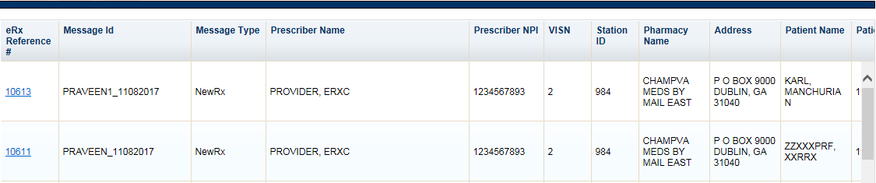

Figure 2‑25: Track/Audit Grid View

##### NewRx Message

The NewRx detail screen displays the new eRx from an external provider.

To access the NewRx detail screen, select the hyperlink in the “eRx Reference #” column.

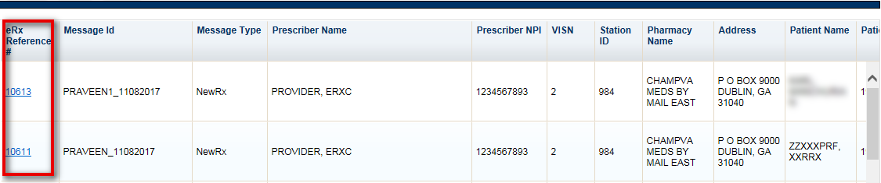

Figure 2‑26: eRx Reference # Hyperlink

The details of the NewRx message display, including the following sections:

* Pharmacy
* Prescriber
* Patient
* Prescription

The eRx Reference # is located in the Prescription section of the screen, as illustrated in the figure below.

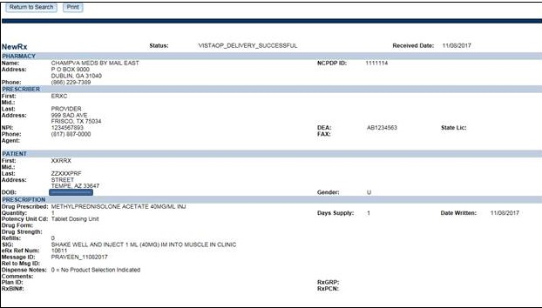

Figure 2‑27: Track/Audit Detail Screen for NewRx Message Type

To return to the search results screen, select the **Return to Search** button. To print the eRx details, select the **Print** button.

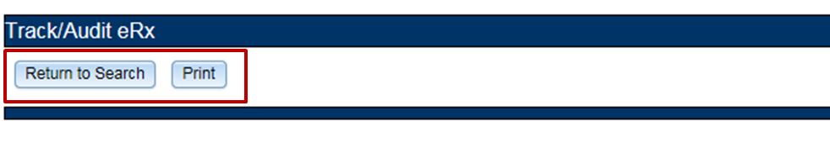

Figure 2‑28: NewRx Detail Screen: Available Actions

##### Error Messages

Error messages can be either generated by the Processing Hub or generated by VistA. Examples of Processing Hub errors include, but are not limited to, Pharmacy not found, Pharmacy not enabled, NCPDP corrupted, and VistA transmission failed. Errors from VistA include the Reject messages sent back when a user rejects an eRx in the Holding Queue.

To access the Error message detail screen, select the hyperlink in the “eRx Reference #” column.

The Error message detail screen displays the error message details sent and received by the Processing Hub.

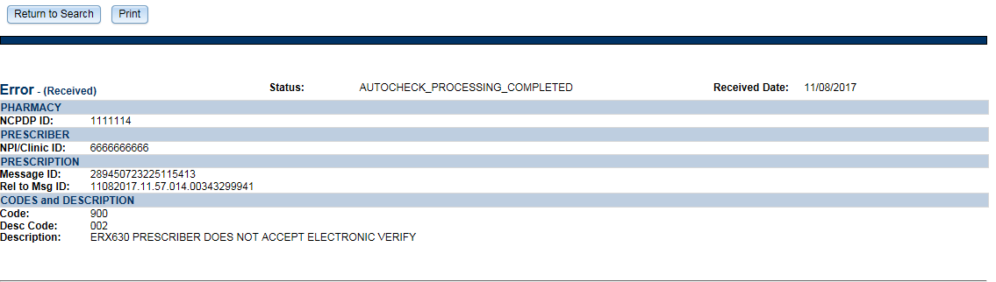

Figure 2‑29: Track/Audit Detail Screen for Error Message Type

The details of the Error message include the following sections:

* Pharmacy: Includes the NCPDP ID of the pharmacy
* Prescriber: Includes the NPI number of the prescriber
* Prescription: Includes the Message ID and Relates to Message ID
* Codes and Description: Includes the Code, Description Code, and Description in the message. Refer to Appendix B. NCPDP Error Codes.

To return to the search results screen, select the **Return to Search** button. To print the Error message details, select the **Print** button.

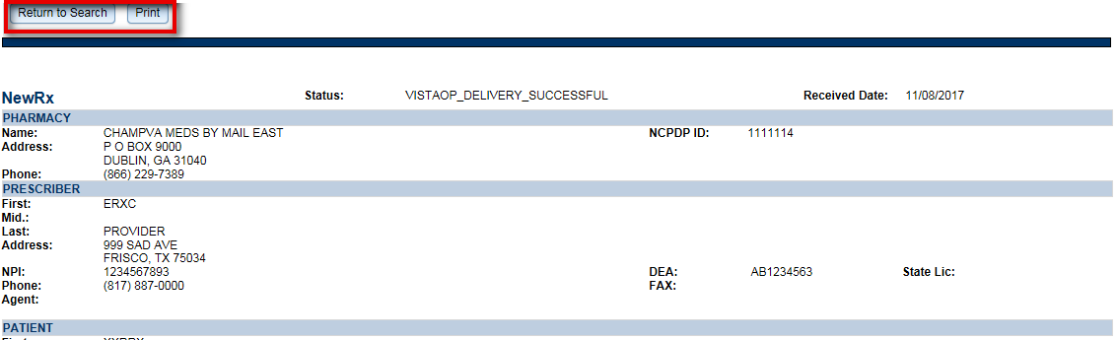

Figure 2‑30: Track/Audit Detail Screen - Return to Search/Print Buttons

##### Verify Messages

Verify messages are sent when the transmission of an eRx from the Processing Hub to VistA is successful.

To access the Verify message detail screen, select the hyperlink in the “eRx Reference #” column.

The Verify message detail screen displays the verify message details sent by the Processing Hub.

**NOTE:** To search for Verify messages, select “Sent” from the **Sent or Received** drop down menu.

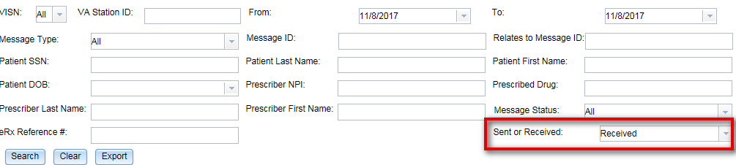

Figure 2‑31: Track/Audit Screen Criteria - Sent or Received Dropdown

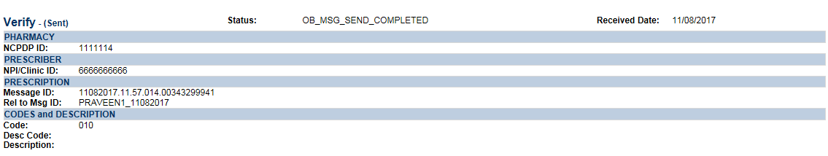

Figure 2‑32: Track/Audit Detail Screen Status/Verify Message Type

The details of the Verify message include the following sections:

* Pharmacy: Includes the NCPDP ID of the pharmacy
* Prescriber: Includes the NPI number of the prescriber
* Prescription: Includes the Message ID and Relates to Message ID
* Codes and Description: Includes the Code, Description Code, and Description in the message. Refer to Appendix B. NCPDP Error Codes.

To return to the search results screen, select the **Return to Search** button. To print the Verify message details, select the **Print** button.

##### Status Messages

A Status message is received when an outbound message from the Processing Hub or VistA reaches CH and/or the external provider successfully.

To access the Status message detail screen, select the hyperlink in the “eRx Reference #” column.

The Status message detail screen displays the status message details received by the Processing Hub.

**NOTE:** To search for Status messages, select “Received” from the **Sent or Received** drop down menu.

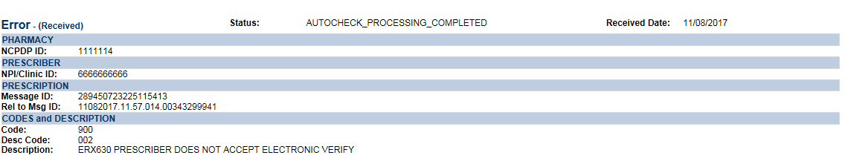

Figure 2‑33: Track/Audit Detail Screen Status Message Type

The details of the Status message include the following sections:

* Pharmacy: Includes the NCPDP ID of the pharmacy
* Prescriber: Includes the NPI number of the prescriber
* Prescription: Includes the Message ID and Relates to Message ID
* Codes and Description: Includes the Code, Description Code, and Description in the message, where applicable. Refer to Appendix B. NCPDP Error Codes.

To return to the search results screen, select the **Return to Search** button. To print the Status message details, select the **Print** button.

### Reports

The Reports tab is used to generate high-level reports on total number of eRxs, grouped by various statuses/errors within a VISN or within a pharmacy. From the Reports tab, users can generate, view, and export a Summary Report.

**Summary Report**

The Summary Report provides a summary of eRx auto-validation checks. To run a Summary Report:

1. From the Reports screen, select **Summary Report** from the “Select Report” drop down.

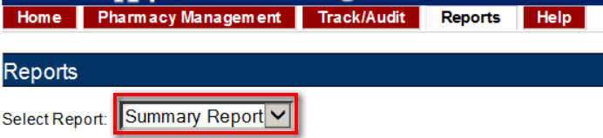

**Figure 2‑34: Summary Report Dropdown**

1. Select the desired VISN from the “VISN” drop down. The drop down contains each VISN number as well as an **ALL** selection to select all VISNs.

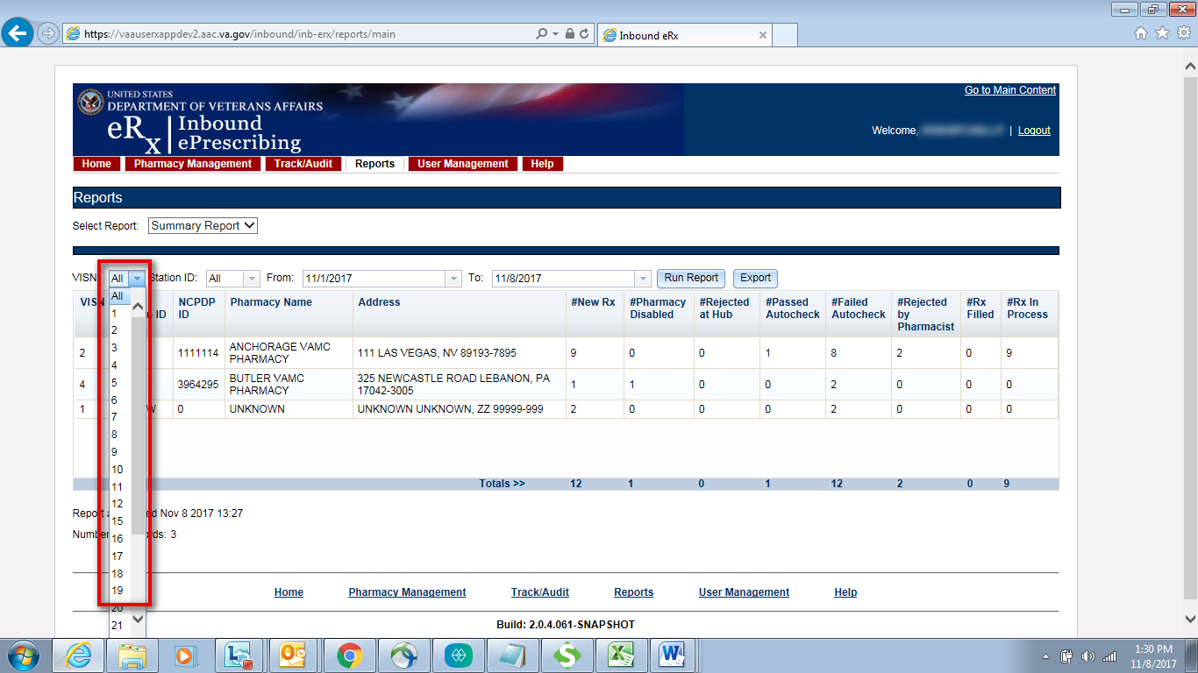

**Figure 2‑35: Reports Screen Filter Criteria – Select VISN from Dropdown**

1. To narrow the search by VA Station ID, select the Station ID for the report.

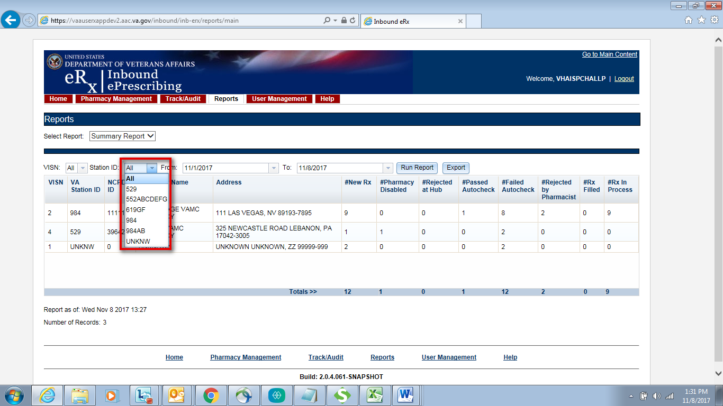

**Figure 2‑36: Reports Screen Filter Criteria - Select Station ID from Dropdown**

1. Select the date range from the Calendar drop down for the report or enter a date using the MM/DD/YYYY format.

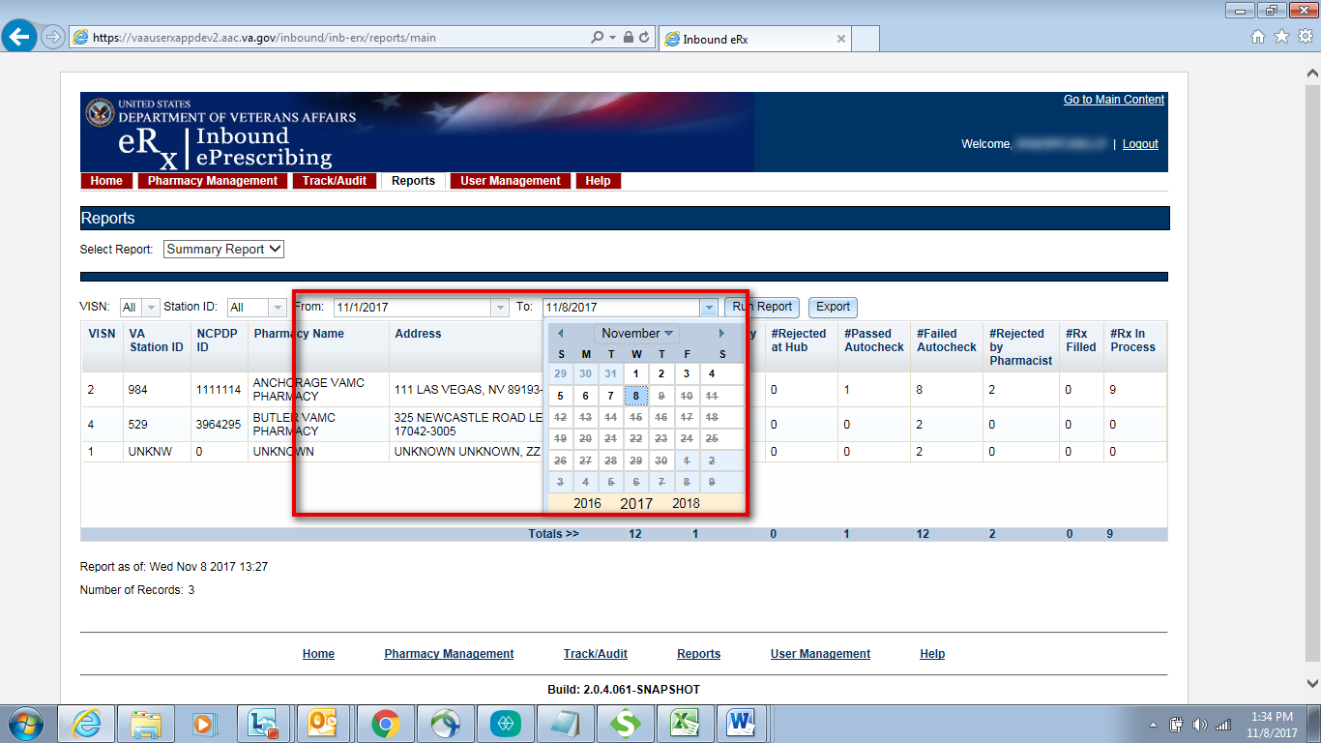

**Figure 2‑37: Reports Screen Filter Criteria - Select Date Range**

1. Select the **Run Report** button to generate the report.

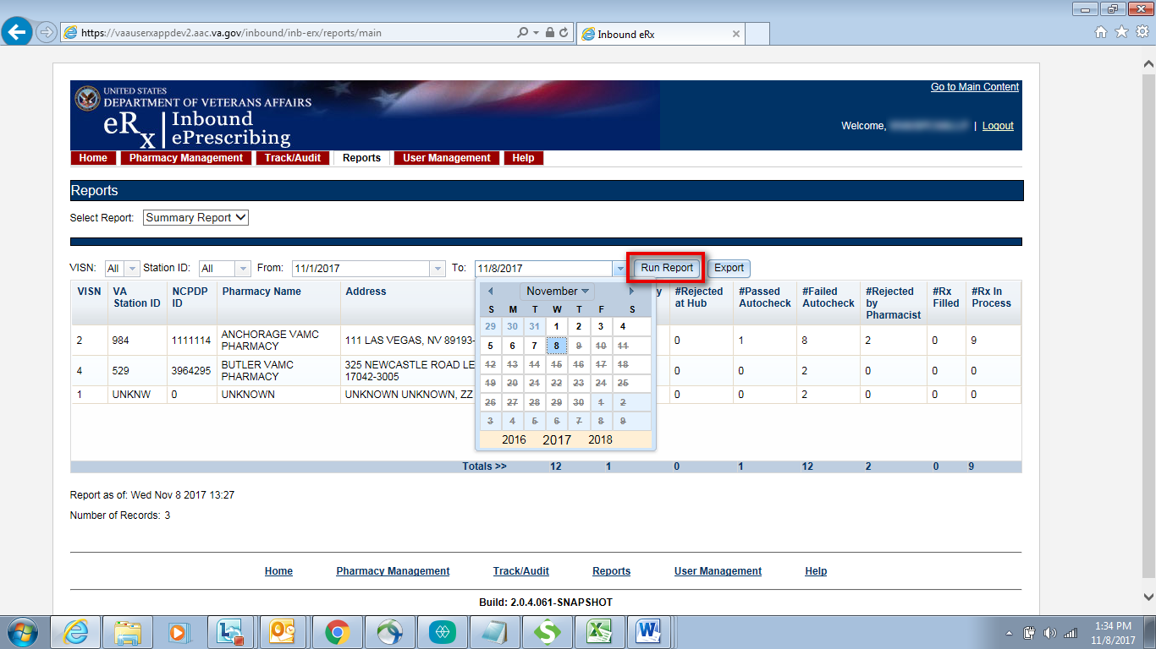

**Figure 2‑38: Run Report Button**

The summary report results display.

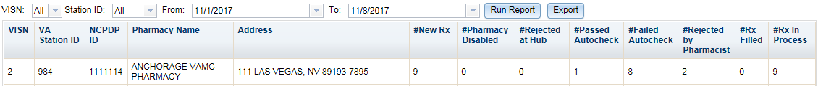

**Figure 2‑39: Summary Report Results**

The Summary Report fields are described in the table below

**Table 6: Summary Report Columns**

| Field | Description |
| --- | --- |
| VISN | Pharmacy VISN number |
| VA Station ID | VistA pharmacy identification number |
| NCPDP ID | National Council for Prescription Drug Programs (NCPDP) identification number |
| Pharmacy Name | VistA pharmacy name |
| Address | Pharmacy address |
| #NewRx | Number of New eRxs |
| #Pharmacy Disabled | Number of messages rejected because of the pharmacy not accepting eRxs (eRxs disabled) |
| #Rejected at Hub | Error messages sent from the Processing Hub to external provider |
| #Passed Autocheck | Number of eRxs that passed all autocheck criteria |
| #Failed Autocheck | Sum of failures for Patient, Provider, and Drug auto-validation checks |
| #Rejected by Pharmacist | Number of rejection messages sent by VistA |
| #Rx Filled | Number of RxFill messages received by the Processing Hub from VistA |
| #Rx In Process | Number of Inbound messages –(minus) number of failures and rejections –(minus) number filled. |

### Export Reports

From the Reports tab, users may export a report to a .CSV format.

To Export a report:

1. Select the **Export** button.

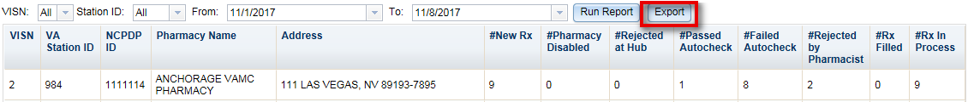

Figure 2‑40: Export Report Buttons

A prompt displays asking to Open or Save the report.

1. Select **Open** to view the report.
2. To save the report, select **Save**. The system displays a Save As dialog. Navigate to a location on your system to save the file.



Figure 2‑41: Summary Report Export Prompt (after clicking Export Button)

### User Management

The User Management screen allows Administrators to add new users to one or more sites (Station ID), enable users, disable users, modify user roles and existing user records by assigning them to one or more sites. This screen will only display for users with Administrator access.

The User Management screen currently displays the list of all users that are added to this system along with their roles and privileges. Please note the user list is currently sorted by First Name.

#### Add New User

System Administrators have the ability to add new users from the User Management screen.

To add a new user:

1. Enter the new user’s User ID, First Name, and Last Name.

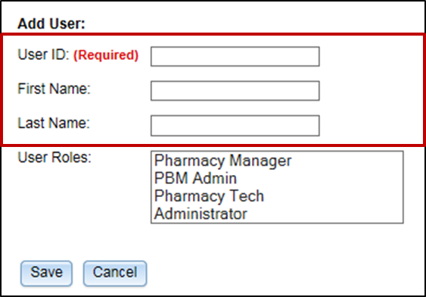

Figure 2‑42: Add User - User ID, First Name, Last Name

1. Select the new user’s role(s). Multiple roles may be selected by holding <**Ctrl**> while selecting more than one role.

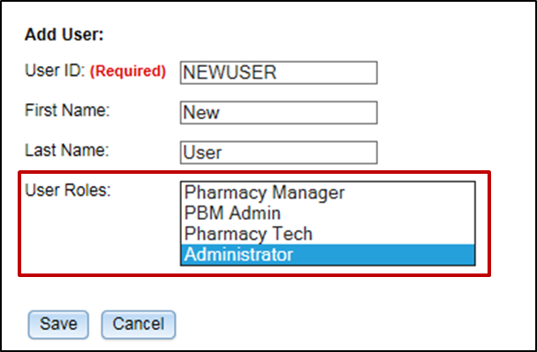

Figure 2‑43: Add User - Select User Roles

1. Select **Save** to add the new user to the users list. To cancel adding a new user, select **Cancel**.

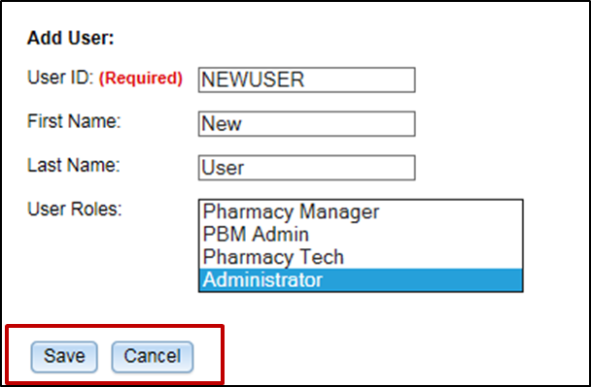

Figure 2‑44: Add User - Save and Cancel

#### Modify User Roles

To modify user roles:

1. From the users list, locate the user and then select the checkbox(es) for the desired user role(s).

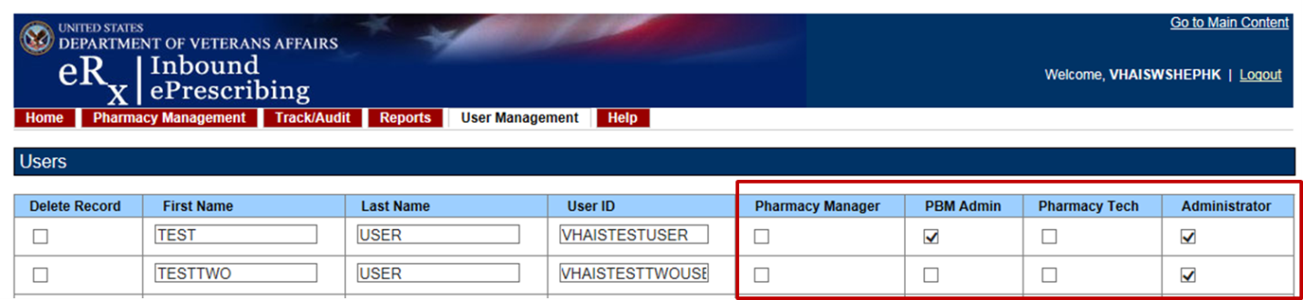

Figure 2‑45: Select User Roles

1. Click **Save** at the bottom of the screen.
2. A message displays indicating that the user was updated successfully.

The Administrator may also select **Cancel** to cancel modifying user roles.

#### Delete Users

To delete a user from the application, locate a user in the user management table. Click the checkmark in the **Delete Record** column and click **Save**. A message displays indicating that the user’s record was deleted successfully from the application.

### Help Desk

For issues with the IEP Web-based application that cannot be resolved by this manual or the site administrator, please contact the National Service Desk at 855-NSD-HELP (673-4357) and reference “Inbound eRx”.

#### Help Desk Ticket Instructions

To submit a Help Desk ticket:

1. Select the “Your IT” icon on your desktop



Figure 2‑46: YourIT Desktop Icon

The homepage displays.

1. Select **Incident**

**NOTE:** Do not select “Incidents” under the Self Service section. Scroll to the Incident section. If the Incident section is collapsed, select **Incident** to expand the section.

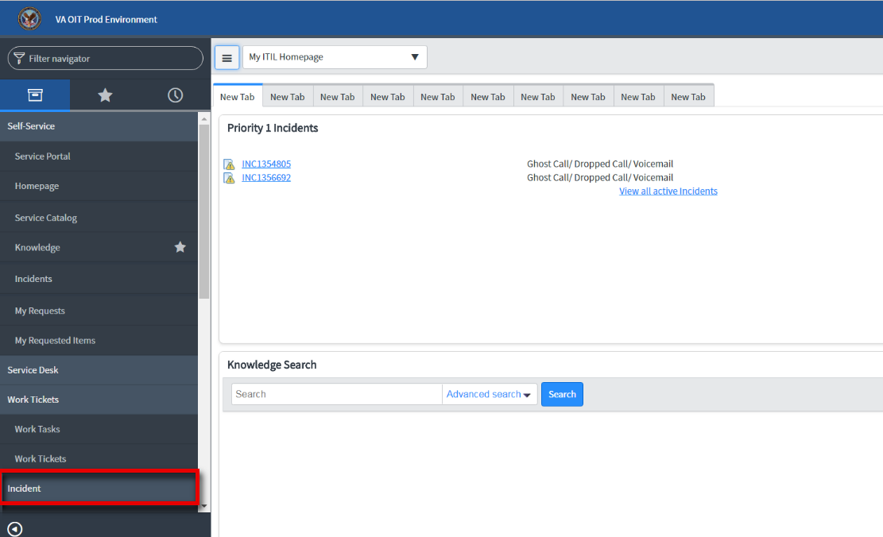

Figure 2‑47: Incident Section

1. Select **Create New**

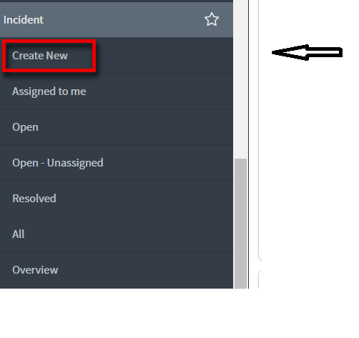

Figure 2‑48: Create New

1. Populate the required fields

**NOTE:** In the “Assignment Group” field, enter “Pharmacy Reengineering Inbound e-Prescriptions”

1. Select **Submit**

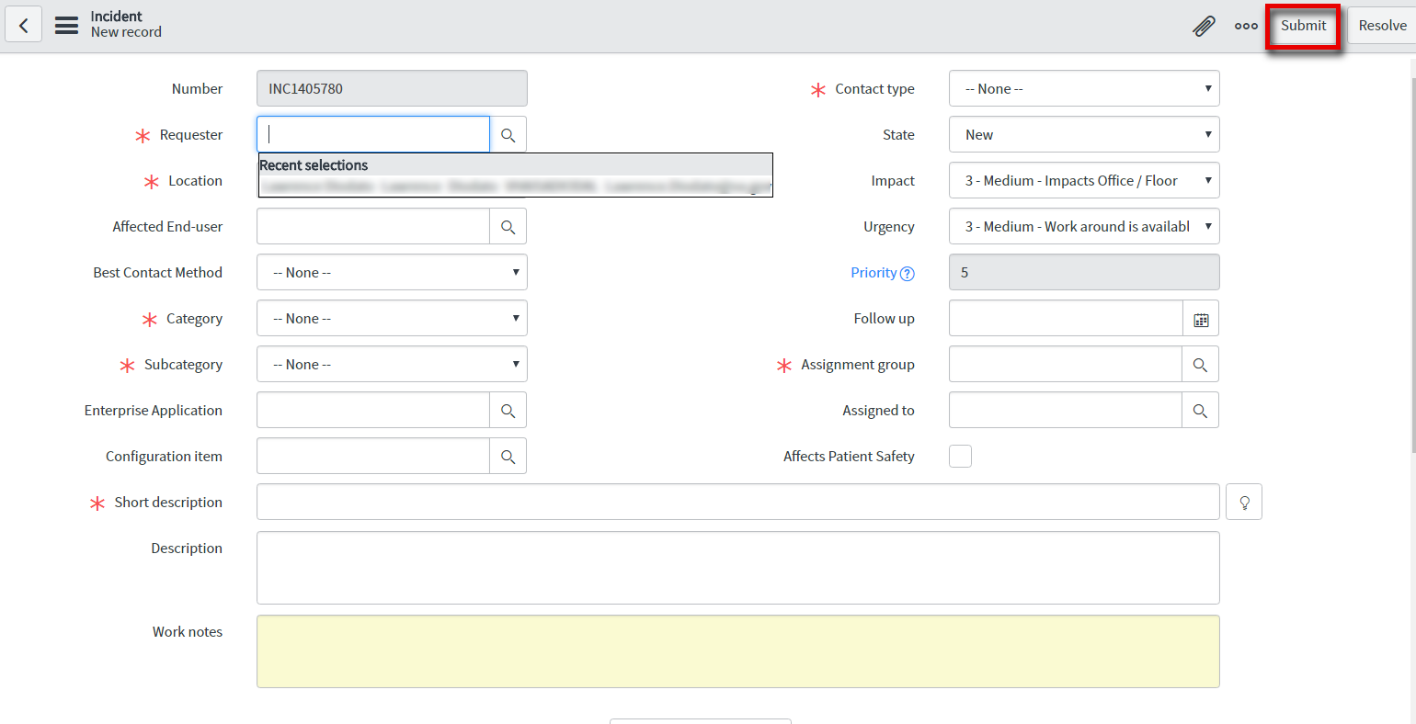

Figure 2‑49: New Incident

### Fax Failover

When Change Healthcare attempts to send an eRx to a pharmacy, but VA Inbound eRx Processing Hub does not send an NCPDP STATUS message back before the request times out, a “FAX failover” occurs. Change Healthcare delivers the eRx message via FAX using the FAX number on record of the destination pharmacy. A failover to FAX is a rare occurrence. VA Pharmacies need to process eRx records received via FAX as non-electronic Rxs. There will be no record of these FAX messages in either the Inbound eRx Processing Hub or the VistA OP Holding Queue.

# VistA Outpatient Pharmacy eRx Holding Queue

## Purpose

The VistA OP eRx Holding Queue allows VA Pharmacy Users to validate and process Inbound eRxs from external providers. The eRx Holding Queue options are new options in the existing VistA OP system.

## Setting Up Default eRx Clinic (Optional)

Sites are encouraged to edit their OUTPATIENT SITE file (#59) to define the default eRx clinic. The following field is added to the OUTPATIENT SITE file (#59): DEFAULT ERX CLINIC field (#10).

Please reference the Implementation Guide - Inbound ePrescribing (PSO*7*0*p527) on the VA Documentation Library (VDL) at the following link for details on setting up the default eRx clinic for a site.

Outpatient Pharmacy VDL URL: <https://www.va.gov/vdl/application.asp?appid=90>

## Accessing the eRx Holding Queue

VA Pharmacies can only accept inbound eRxs through an eRx Processing Hub that interfaces to external providers capable of transmitting eRxs. The eRx message is transmitted from the Processing Hub to VistA OP and initially stored in the eRx Holding Queue.

The eRx Holding Queue is functionality in VistA OP that has been added for Inbound eRx processing. It allows for validation and review of eRxs by VA pharmacy users prior to the eRx being added to the VA record and merging with the existing outpatient functionality. VA Pharmacy users can validate patient, provider, Drug/SIG information. Additionally, users can accept, hold, print, reject, or remove an eRxs from the Holding Queue after it has been received by VistA from the eRx Processing Hub.

To access the eRx Holding Queue follows this navigation path:

Core Applications>>PS Pharmacy Menus>>Outpatient Pharmacy Manager>>(select Division)>>Rx (Prescriptions)>>Complete Orders from eRx [PSO ERX FINISH]

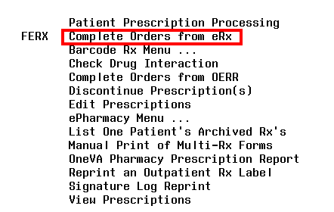

Figure 3‑1: Complete Orders from eRx Menu Option

The first screen that displays upon accessing the eRx Holding Queue is the Holding Queue list screen.

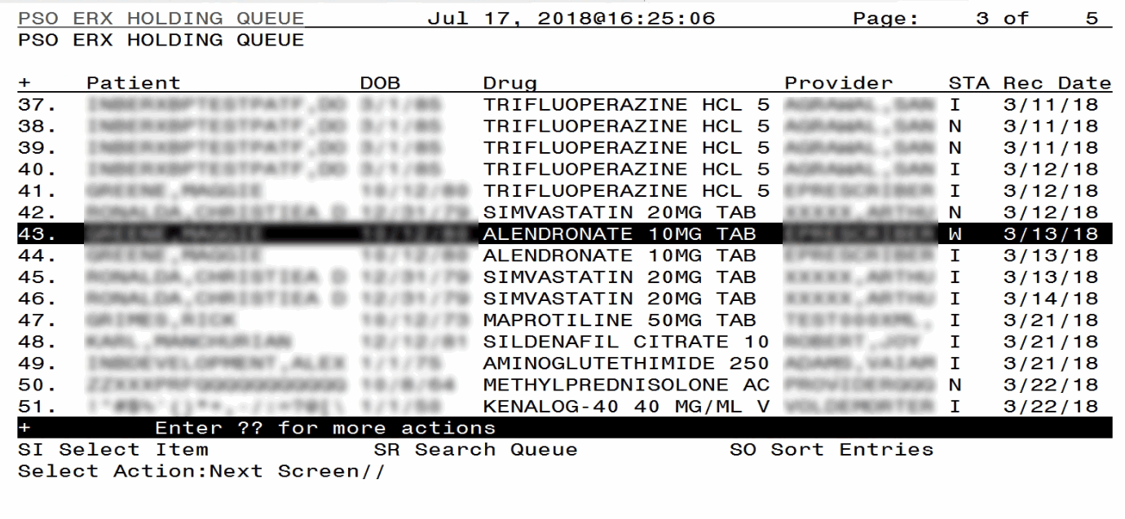

Figure 3‑2: eRx Holding Queue List View

## eRx Holding Queue List View

The eRx Holding Queue list columns include the patient’s name (Patient), date of birth of the patient (DOB), the prescribed drug from the external provider (Drug), the prescribing physician’s name (Provider), the status of the eRx (STA), and the date that the eRx was received by VistA (Rec Date). At any given time, 999 eRx records are displayed in the Holding Queue list view with statuses of “N”, “I”, “W”, or with one of the Hold codes. The records are sorted by Received Date with oldest records first. (Refer to Appendix A. Holding Queue Status Codes & Descriptions for more information on the various statuses in the list.)

The following actions are available from the eRx Holding Queue list:

* <**SI> Select Item** can be entered to select an item in the Enter a Number prompt. Additionally, the record # can be entered without selecting SI at the “Select Action: Next Screen//” prompt.
* <**SR> Search Queue** can be entered to search for an eRx based on a variety of search criteria. Refer to the Search eRxs section for additional information.
* <**SO> Sort Entries** can be entered to sort the list. Refer to the Sorting eRxs section for additional information.

Note that the default sort order on the initial list display is the following:

* Date Received - Oldest to Newest
* Secondary sort by Patient Name



Figure 3‑3: eRx Holding Queue List View

### eRx Default Lookback Days

A new field, ERX DEFAULT LOOKBACK DAYS (#10.2), has been added to the OUTPATIENT SITE file (#59). It contains the number of days the user would like to look back before loading the Holding Queue’s List View or completing a Search (SR) or Sort (SO). This is a configurable field that can be updated with the desired value by the local site’s VistA Admin. The addition of this new configurable field facilitates increased processing speed in the eRx Holding Queue.

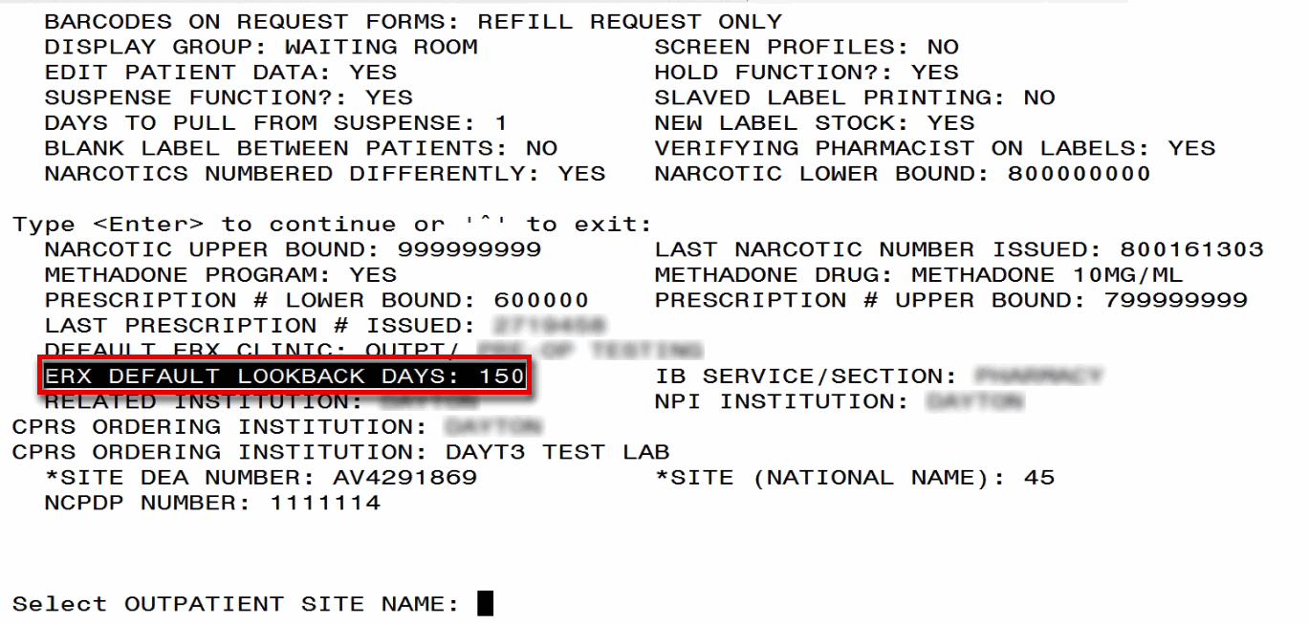

Figure 3‑4: eRx Default Lookback Days

* The number of eRx records displayed in the Holding Queue’s list view is based on the ERX DEFAULT LOOKBACK DAYS (#10.2) configured in OUTPATIENT SITE file (#59).
* By default, the ERX DEFAULT LOOKBACK DAYS field is blank, so the software will go back to 356 days.
* If the Pharmacy user would like to see eRx records received from older dates, s/he can use the Search (SR) option and select the ‘Received Date Range’ (#3), to retrieve those records.

**NOTE:** Refer to the Implementation Guide - Inbound ePrescribing (PSO*7*0*p527) on the VA Documentation Library (VDL) for details on configuring the ERX DEFAULT LOOKBACK DAYS for a site.

## eRx Holding Queue Summary Screen

A user can select a record from the eRx Holding Queue List View by both typing <**SI**> and the record number or by typing the record number itself. The first screen displayed is the Summary Screen, which displays information about the original eRx from the external provider and matched VistA information (if any).

On this screen, the header contains the eRx Patient Name and eRx Reference #, which is an internal VA reference number assigned for tracking the eRx. Below the header is information received from the external provider for the patient, provider, and the Drug/SIG. Where applicable, VistA information displays below the eRx information.

Press <**Enter**> to display Page 2 of the Summary Screen, which contains eRx  notes, applicable Allergy information, and Diagnosis information displayed in a compressed format.

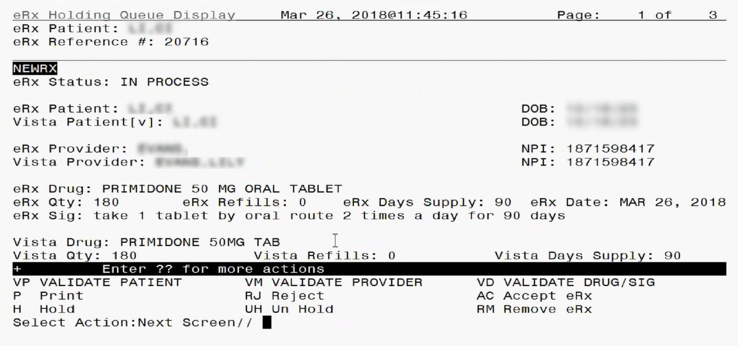

Figure 3‑5: Summary Screen Page 1

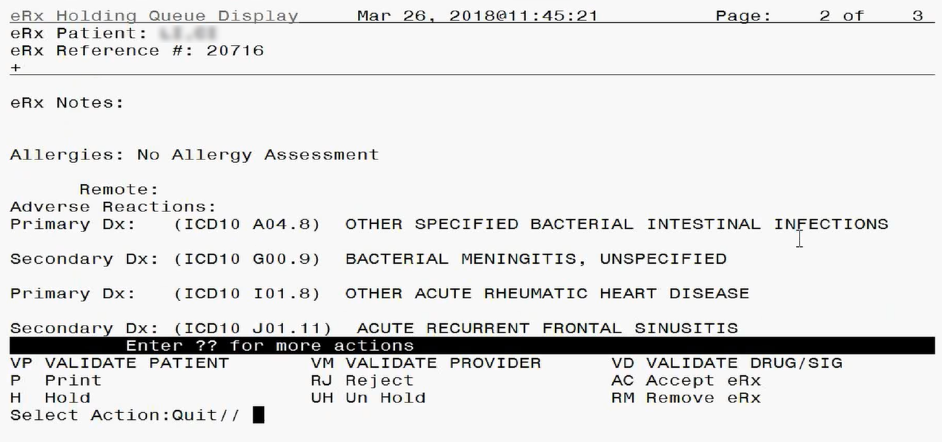

Figure 3‑6: Summary Screen Page 2

If the VistA information for the patient, provider, or drug is not linked, the display would be as shown below:

* VistA Patient: NOT LINKED
* VistA Provider: NOT LINKED
* VistA Drug: NOT LINKED

VistA information displayed includes allergies. If the patient has no known allergies, “NKA” displays in the Allergies section.

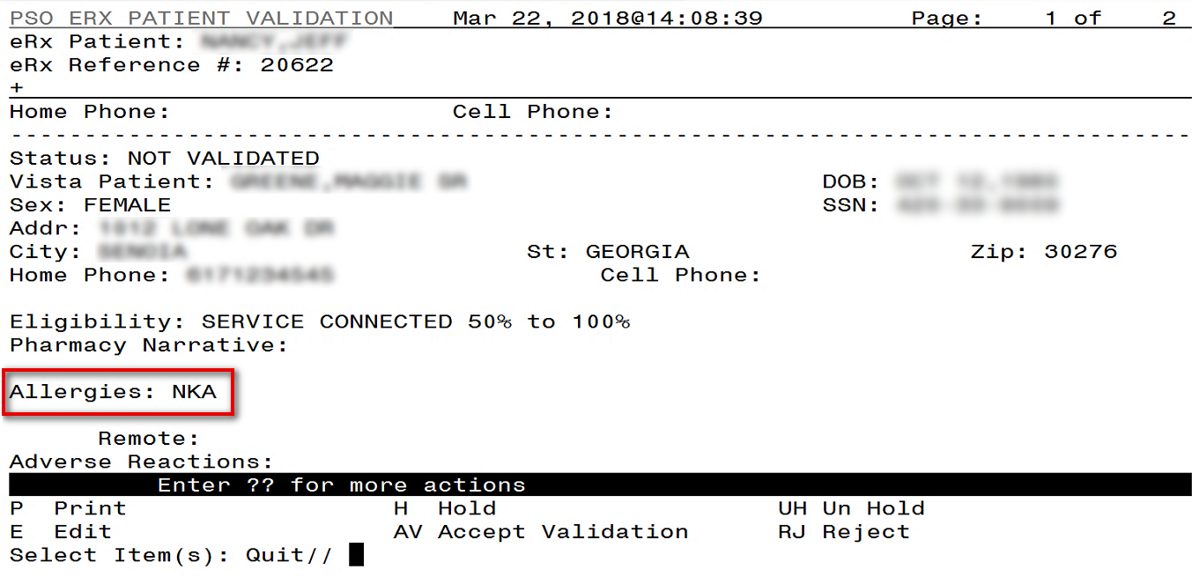

Figure 3‑7: Patient with No Known Allergies

If the VistA patient has known allergies, verified allergies display in the Allergies section.

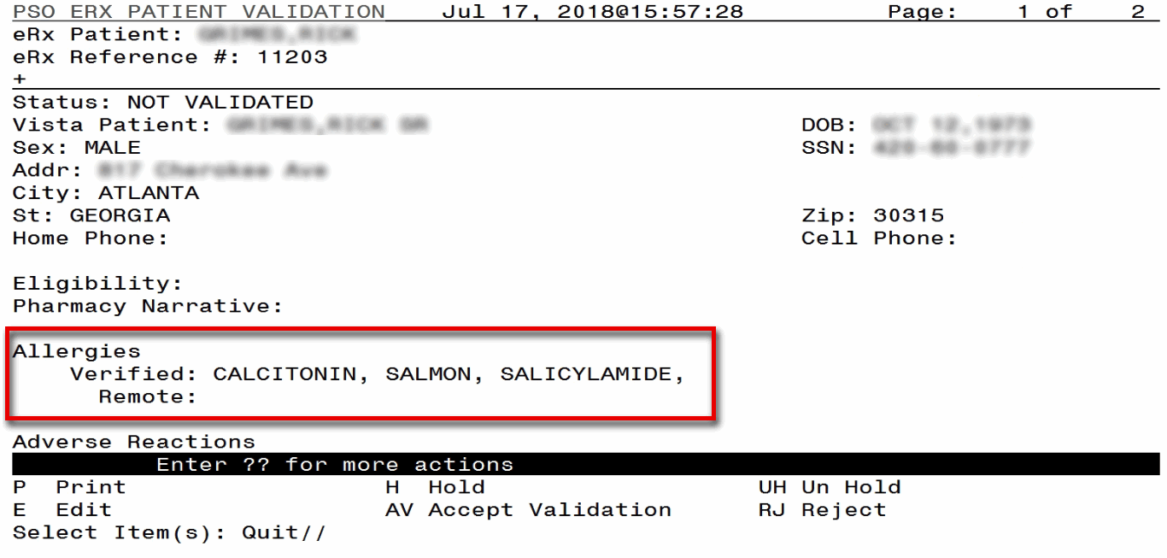

Figure 3‑8: VistA Patient with Known Allergies

### eRx Actions

* Manual Validation:
  + <**VP>** Validate Patient
  + <**VM>** Validate Provider
  + <**VD>** (Validate Drug/SIG) - Note that this action is not be available unless a VistA patient has been linked, as indicated with parenthesis around the action.
* <**AC>** Accept eRx: Action is not available until the validation of the eRx patient, provider, and Drug/SIG have been completed. Also note that the <**AC**> action will not be available if the eRx is on Hold.
* <**RJ>** Rejecting eRxs: Rejects an eRx.
* <**P>** Print: Displays all details of an eRx and allows the user to select a local printer and print the eRx.
* <**H>** Hold: Place an eRx on Hold.
* <**UH>** Un Hold: Remove eRx from a Hold.
* <**RM>** Removing eRxs: Removes eRx from the main list display and prevents further processing of the eRx.
* **<??>**For hidden actions. For more details on the above actions, please refer to the sections identified.

**NOTE:** From the Summary Screen, users cannot edit any of the VistA information. The validate screens contain the option for editing the VistA information. For further information on editing and validating VistA information for an eRx, please refer to the Manual Validation section.

### Patient-Level Record Lock

Note that when either the Summary screen or any of the validate screens of an eRx are open, all the eRxs for that same patient in the Holding Queue are locked and inaccessible for other users to access until the lock is released (the screens are closed). This is referred to as a patient-level record lock.

The following message displays if a user attempts to access an eRx for the same patient that another user has opened.



Figure 3‑9: Patient-Level Record Lock

## Manual Validation

Prior to accepting an eRx (AC) and moving the eRx to Pending Outpatient Orders file, the VistA patient, provider, and Drug/SIG must be validated. The eRx will then be further processed using Patient Prescription Processing [PSO LM BACKDOOR ORDERS] or Complete Orders from OERR [PSO LMOE FINISH].

The validation process begins by selecting one of the validate actions from the Summary screen.

**NOTE:** Before the Drug/SIG on an eRx can be manually validated, the eRx Patient must have a linked VistA patient. The <**VD>** (Validate Drug/SIG) action will have parenthesis around the action to signify this action is not available until a VistA patient is linked as illustrated in the figure below.

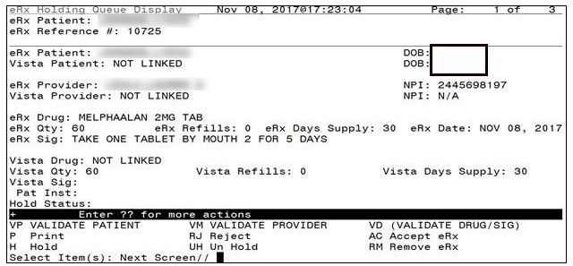

Figure 3‑10: Summary Screen Actions

### Validate Patient

The patient must be validated before an eRx can be accepted. Refer to Accept eRx. Information about the Patient Validation screen and editing the patient information is described in the following sections.

To validate patient information, type <**VP>** VALDIATE PATIENT from the Summary screen. The Patient Validation screen displays and is described in the following sections.

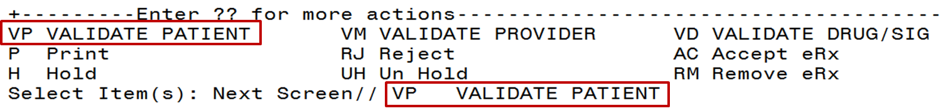

Figure 3‑11: Validate Patient

#### Patient Auto-Match in the Processing Hub

The following outlines the scenarios for a patient auto-match in the IEP Processing Hub before being sent down to VistA:

Patient Match - Primary Hub:

1. MVI Check - receive ICN and SSN from MVI if successful.
2. If SSN is sent on a new eRx (NEWRX), then the SSN will be used in the auto-match with the MVI along with Last Name, First Name, DOB, Gender, Address Line 1, and Home Telephone Number.
3. If SSN is not sent on the NEWRX, then the match will be done with MVI against Last Name, First Name, DOB, Gender, Address Line 1, and Home Telephone Number.
4. Since only the Last Name, First Name, DOB, and Gender are mandatory on a NEWRX, the match will be done against all the data pieces that are received.
5. When a patient is successfully matched, the patient registration at the sites will be checked.
6. E&E Check - Then E&E Services is checked to see if the patient is both enrolled and eligible to their system to receive pharmacy benefits (This is done using ICN retrieved from MVI).

Patient Secondary Match in VistA:

* Case 1: Patient Auto match successful (MVI record found, E&E check passed and Patient Site Registration passed).

1. Use the ICN received from MVI and check against the local Patient file entry; if passed, then link this VistA patient to eRx Patient.
2. If ICN check fails, use the SSN received from MVI and check against the local Patient file entry; if passed, then link this VistA patient to eRx Patient.

* Case 2: MVI Match successful but E&E check failed at the Hub:

1. Use the ICN received from MVI and check against the local Patient file entry; if passed, then link this VistA patient to eRx Patient.
2. If ICN check fails, use the SSN received from MVI and check against the local Patient file entry; if passed, then link this VistA patient to eRx Patient.

* Case 3: MVI match unsuccessful at the Hub

1. No secondary match.

#### Patient Manual Validation Screen Overview

The header of the Patient Validation screen contains the eRx Patient Name and the eRx Reference #. Below the header is the eRx and VistA information for the patient, including any known allergies where applicable.

**NOTE:** The eRx Patient information is display-only and cannot be edited.

If a match was NOT found for the eRx Patient, the screen looks similar to the below figure. The Status field has “NOT VALIDATED”, with “PATIENT NOT MATCHED” below the Status. No VistA patient information displays.

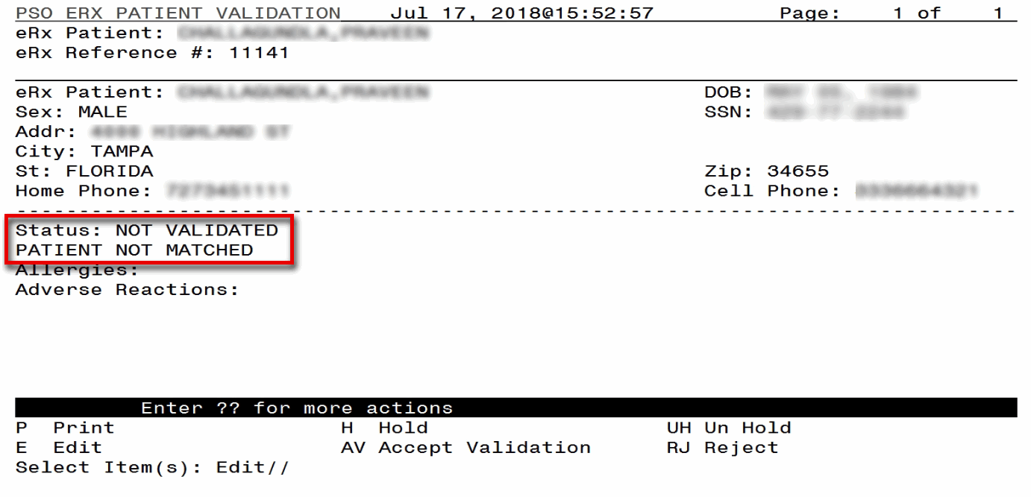

Figure 3‑12: Patient Validation Screen Display - Patient Not Validated/ Not Auto Matched

If a match is found, however, the patient has NOT been validated, the Summary screen looks similar to the below figure. The Status field has “NOT VALIDATED”, with VistA information displaying, where applicable.

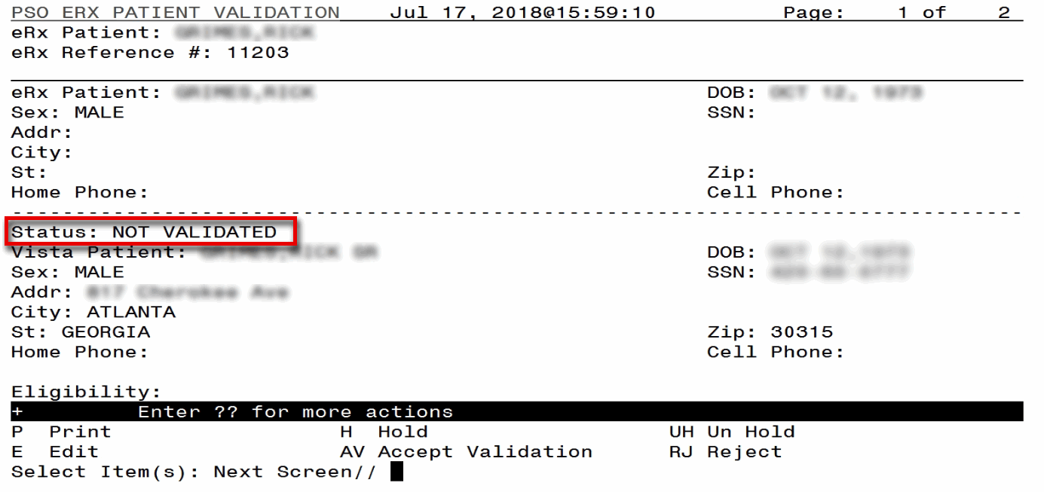

Figure 3‑13: Patient Validation Screen Display - Patient Not Validated / Patient Auto Matched

If the VistA patient has known allergies, verified allergies display in the Allergies section.

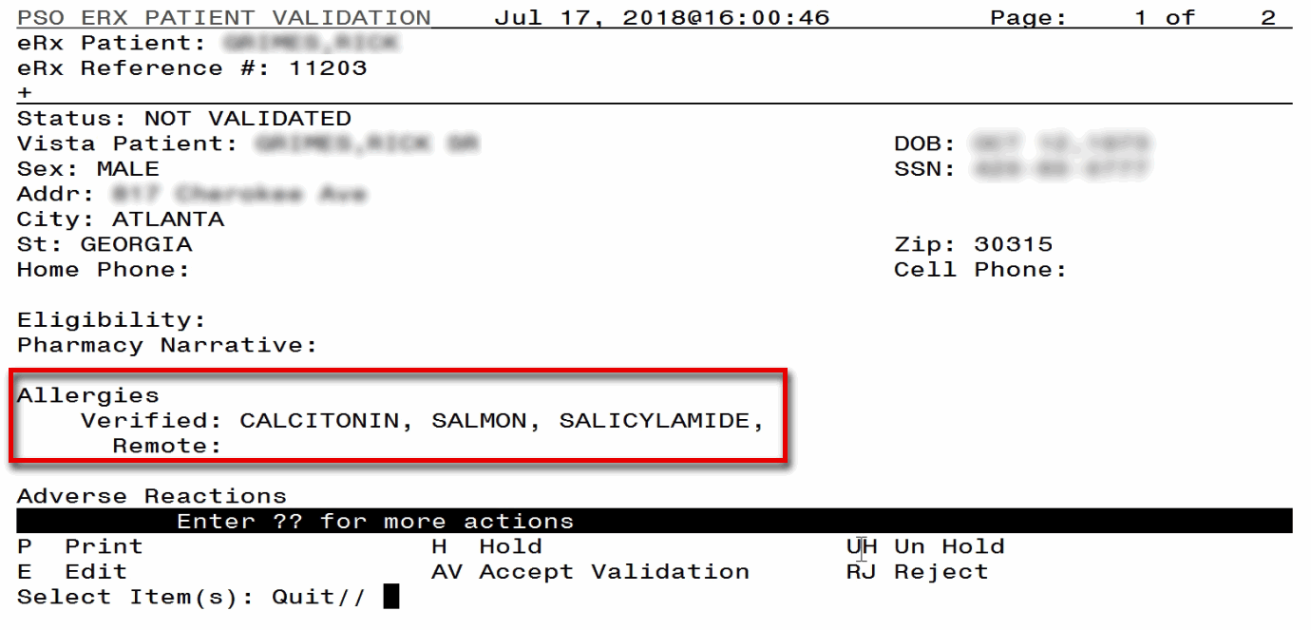

Figure 3‑14: VistA Patient with Known Allergies

If the patient has been validated, the Status field above the VistA Patient contains “VALIDATED”, with the user who performed the validation and date/timestamp.

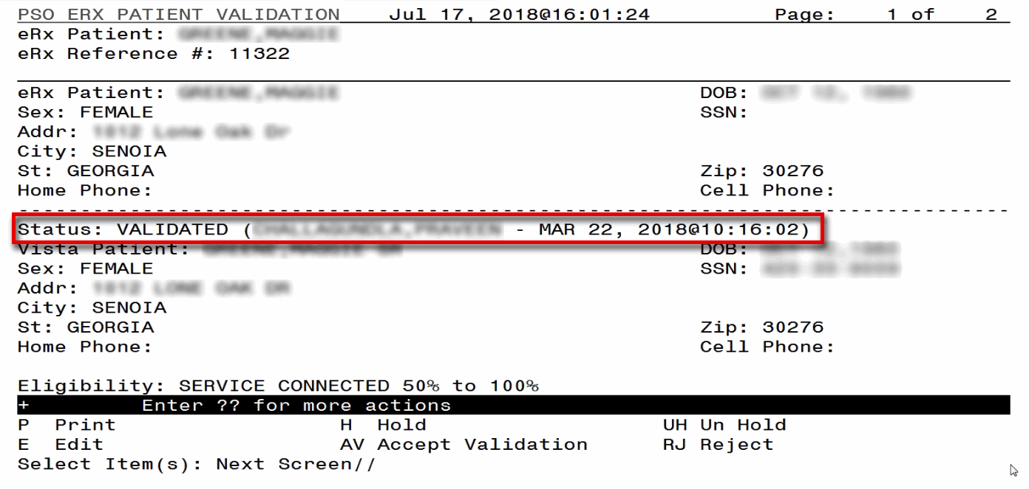

Figure 3‑15: Patient Validated

The actions at the bottom of the Patient Validation screen include:

* <**P>** Print – Prints display of the eRx for printing to network or local printer.
* <**H>** Hold – Places an eRx on hold.
* <**UH>** Un Hold – Removes an eRx from a Hold
* <**E>** Edit – User edits if the information is empty or incorrect
* <**AV>** Accept Validation – User accepts the validation if information is correct
* <**RJ>** Reject – Rejects the eRx

#### Edit Patient

1. Enter <**E>** Edit to edit the patient information.
2. If a VistA patient already exists for the eRx, the system displays a message confirming the edit.



Figure 3‑16: Edit Patient on a VistA Match

1. If a VistA patient match does not exist, the system prompts to select a patient at the “Select Patient Name” prompt. The partial or full name of the patient, DOB or SSN can be entered.
2. Select the correct patient and press <**Enter**>.
3. A message displays confirming the patient selection. Enter <**Y**> Yes.
4. The select patient information populates the VistA Patient fields on the Patient Validation screen.

**NOTE:** A Warning Message displays if there is a DOB, Gender, and/or a SSN mismatch on the patient selected during the edit process.

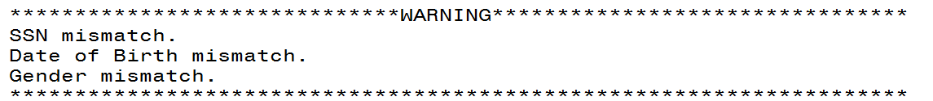

Figure 3‑17: Mismatch Warning Message

#### Accept Patient Validation

Once the patient information has been edited and reviewed for accuracy, the validation needs to be accepted on the Patient Validation screen.

1. Select <**AV>** Accept Validation on the Patient Validation screen to accept the provider validation.
2. A message displays confirming whether or not to mark the patient as validated. Enter <**Y>** Yes.

If the validation is successful, a message displays indicating that the validation was updated.

The Status changes to “VALIDATED” on the Patient Validation screen, along with the user who performed the validation and date/timestamp.

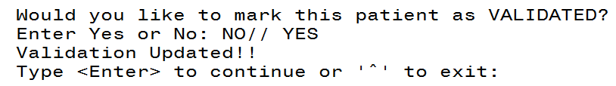

Figure 3‑18: Confirm Acceptance of Patient Validation

A “[v]” displays to the right of the VistA Patient field on the Summary screen.

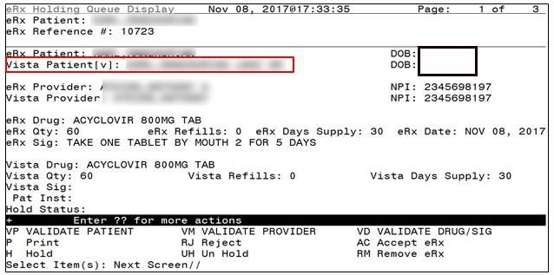

Figure 3‑19: Patient Validation Complete: Summary Screen Indicator

#### Automatic Patient Validation

When a patient validation is accepted on one eRx and there are additional eRxs in the Holding Queue for the same patient, received on the same day, a message displays asking if the patient validation should be applied to the other eRxs. (Refer to the figure below.) If the user selects <**Y**> Yes, the system links and applies the patient validation for the eRxs currently in the Holding Queue for that patient.

The determination of the same patient is based on unique records from the ERX EXTERNAL PATIENT file (#52.46). The system will only validate the same patients on eRxs that are currently in the ERX HOLDING QUEUE file (#52.49) received at the time of the automatic patient validation. Patient validation will not be applied for eRxs received for that patient after the auto validation is applied. For example, if VA receives six eRxs for the same patient on the same day, the user will only have to validate the patient once. If eRxs are received later that same day, those eRxs will need to be revalidated.

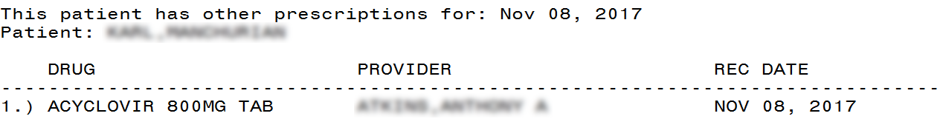

Figure 3‑20: Automatic Patient Validation

To apply patient validation to other eRxs in the Holding Queue for the same patient, received on the same day:

1. The system asks the user if the previous validation should be applied to the other eRxs received for the patient.



Figure 3‑21: Apply Patient Validation to Other eRxs

1. Enter **Y** for Yes to apply the validation to the other eRxs for the patient. After selecting Yes, the patient validation is applied to the other eRxs. As previously noted, any eRxs received after this action will not be validated.
2. A message displays indicating that the validation was updated.
3. A “[v]” displays to the right of the VistA Patient field on the Summary screen and the Status field changes to “VALIDATED” on the Patient Validation screen, along with the user who performed the validation and date/timestamp. This occurs for all the eRxs validated via the automatic patient validation process.
4. The statuses on all eRxs validated by the automatic patient validation process will change to “I” for In Process.

### Validate Provider

The provider must be validated before an eRx can be accepted.

To validate provider information, from the Summary screen, type <**VM**> VALIDATE PROVIDER. The eRx Provider Validation screen displays.

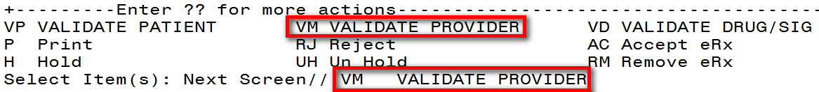

Figure 3‑22: Summary Screen Action - Validate Provider

Information about the Validate Provider display and editing the provider information is described in the following sections.

#### Provider Auto-Match in the Processing Hub

The auto-match on an external provider is based upon the NPI of the prescriber coming in on the new eRx. The NPI is matched against the VistA instance’s NEW PERSON file (#200) entry. If the NPI matches and if the Provider is marked ‘Authorized to Write Meds’ that is considered as a match. Upon successful match, the VistA provider is linked with the incoming provider’s record in VistA.

#### Provider Manual Validation Screen Overview

The header of the Provider Validation screen contains the eRx Patient Name and the eRx Reference #. Below the header is the eRx and VistA information for the provider, where applicable.

**NOTE:** The eRx provider information is display-only and cannot be edited.

If a match was NOT found for the eRx provider, the screen looks similar to the below figure. The Status field has “NOT VALIDATED”, with “PROVIDER NOT MATCHED” below the Status. No provider information displays.

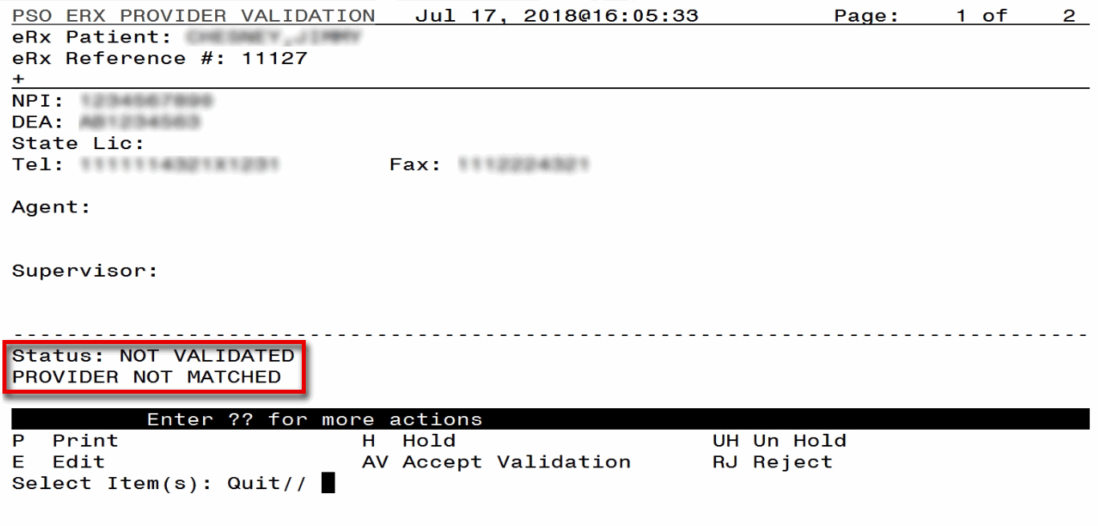

Figure 3‑23: Provider Not Auto Matched / Not Validated

#### Edit Provider

To edit the provider information:

1. Press the <**E>** Edit action on the Provider Validation screen.
2. If no VistA provider information is in the system for the eRx, the “Select Provider Name” prompt displays for searching for and selecting a provider.
3. Enter either the partial name or full name of the provider or the NPI of the Provider, or DEA of the Provider at the “Select Provider Name” prompt. If multiple providers exist with the same name exist, a list of providers is provided with additional identifying information (e.g., middle initial, mail code, and title, where applicable, etc.).
4. Select the provider.
5. If a VistA provider is currently linked for the eRx, the system asks if the current provider should be modified.
6. Enter <**Y>** Yes.
7. Enter either the partial name or full name of the provider at the “Select Provider Name” prompt.
8. Select the provider.

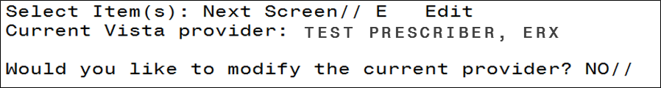

Figure 3‑24: Modify Current VistA Provider

1. Once the VistA provider is selected, the VistA provider fields populate on the Provider Validation screen, along with information whether the DEA of the Provider has expired or not.
2. The next step in in the provider validation process is to accept the validation, which is described in the next section.

#### Accept Provider Validation

Once the correct provider has been selected and reviewed for accuracy, the next step is to accept the validation using the following steps.

1. Select <**AV>** ACCEPT VALIDATION on the Provider Validation screen to accept the provider validation.

**NOTE:** The following warning message displays upon selecting the validation if there is a DEA # and/or NPI mismatch.

Figure 3‑25: Select Provider Warning Message

******************************WARNING********************************

Provider NPI Mismatch.

Provider DEA Mismatch.

*********************************************************************

A message displays confirming whether or not to mark the provider as validated.

1. Enter <**Y**> Yes.
2. If the validation is successful, a message displays indicating that the validation was updated. Type <**Enter**> to continue or '**^**' to Quit.

**NOTE:** If there are other eRxs for the patient, written by the same provider, received on the same day for that patient, a message displays asking if the provider validation should be applied to those eRxs. Refer to the Automatic Provider Validation section for more information.

* The Status field changes to “VALIDATED” on the Provider Validation screen and the user who accepted the validation and date/timestamp displays to the right of “VALIDATED”.
* A “[v]” displays to the right of the VistA Provider field on the Summary screen.

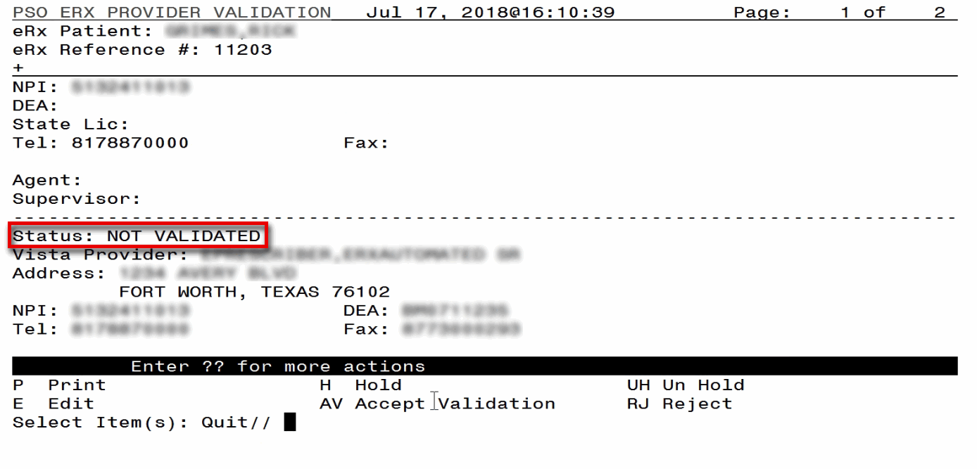

Figure 3‑26: Before Provider Validation (Validate Provider Screen)

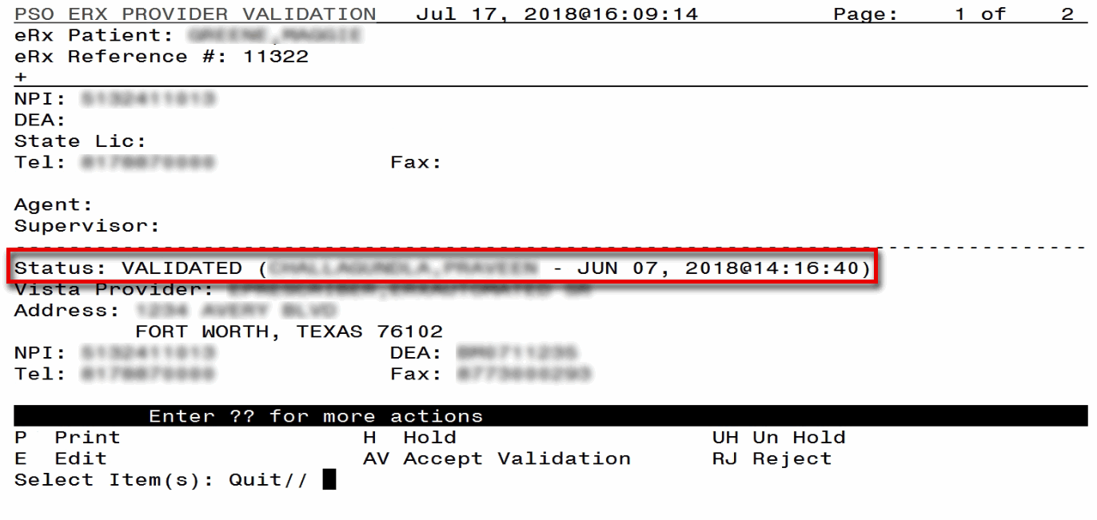

Figure 3‑27: After Provider Validation (Validate Provider Screen)

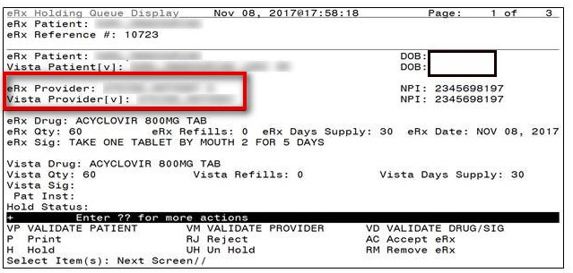

Figure 3‑28: After Provider Validation (Summary Screen)

#### Automatic Provider Validation

When a provider validation is accepted on one eRx and there are additional eRx s in the Holding Queue for the same patient by the same provider, received on the same day, a message displays asking if the other eRxs for the patient written by the provider should be validated. If the user selects <**Y**> Yes, the system links and applies the provider validation for the eRxs currently in the Holding Queue for the patient by the same provider.

The determination of the same provider is based on unique records from the ERX EXTERNAL PERSON file (#52.48). The system only validates the same provider on eRxs that are currently in the ERX HOLDING QUEUE file (#52.49) for the same patient received on the same date. Provider validation is not applied for the same provider received after the auto validation is applied once. For example, if VA receives six eRxs for the same patient on the same day from the same provider, the user only has to validate the provider once; however, if eRxs are received after the automatic provider validation is applied (e.g., later that same day by that provider), the provider for those eRxs needs to be validated.

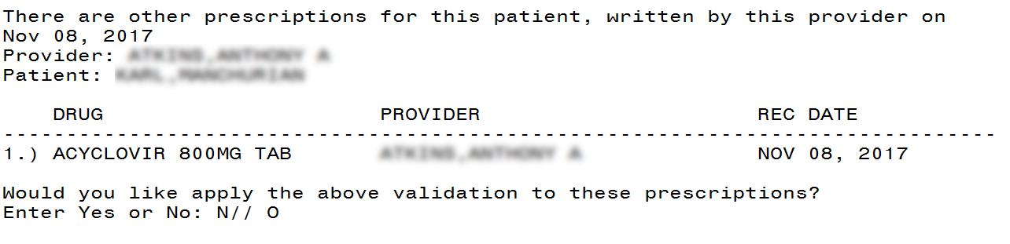

Figure 3‑29: Automatic Provider Validation

To apply the provider validation to the other eRxs enter <**Y**> Yes. A message displays indicating that the validation was updated.

* The Status field on all the eRxs, where the provider validation has been applied, changes to “VALIDATED” on the Provider Validation screen and the user who accepted the validation and date/timestamp displays to the right of “VALIDATED”.
* A “[v]” displays to the right of the VistA Provider field on the Summary screen.
* The statuses on all eRxs validated by the automatic provider validation process will change to “I” for In Process.

### Validate Drug/SIG

The Drug/SIG information on the eRx must be validated before an eRx can be accepted.

**NOTE:** A VistA patient must be linked (matched) before the Validate Drug/SIG action will be available.

To validate Drug/SIG information for the eRx, type <**VD**> Validate Drug/SIG from the Summary screen. The Drug Validation screen displays and is described in the following sections.

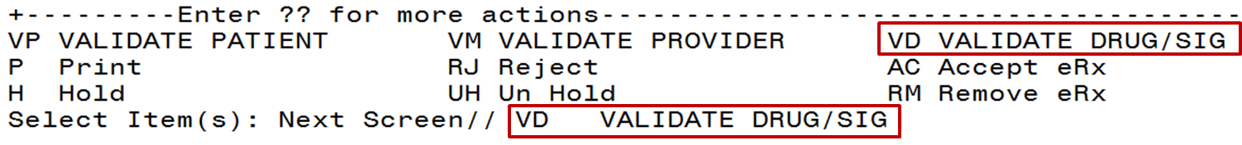

Figure 3‑30: Validate Drug / SIG

#### Drug Auto-Match in the Processing Hub

The pre-conditions for a drug auto-match in the Processing Hub are that the drug should be one-to-one match, should not be a Compound, not a Controlled Substance, should be Active, not Investigational and should be marked for Outpatient use in the local DRUG file (#50).

First, the drug description on the new eRx is matched against the Drug Generic Name entry in the VistA instance’s DRUG file (#50). If successful, the match stops right here and the drug is linked in VistA.

If the match is not successful, the drug description is then matched against the VA Product Name entry in the VistA instance’s VA PRODUCT file (#50.68). Then a drug in local file for the matched VA Product Name is identified, which should satisfy the preconditions. If the match is successful, the drug is linked in VistA.

If the match is not successful, the NDC is used to match against the VistA instance’s NDC/UPN file (#50.67). Using the VA Product Name identified at this step, a drug in the local file for the matched VA Product Name is identified, which should satisfy the preconditions. If the match is successful, the drug is linked in VistA.

**NOTE:** The NDC is an optional field and may or may not be included with the new eRx. For a supply, if UPC is sent, it is not matched against the NDC/UPN file #50.67. Only the Drug Description match is attempted.

#### Drug/SIG Manual Validation Screen Overview

The header of the Drug/SIG Validation screen contains the eRx Patient Name and the eRx Reference #. Below the header is the eRx and VistA information for the Drug/SIG, where applicable.

**NOTE:** The eRx Drug/SIG information is display-only and cannot be edited.

If a match was NOT found for the VistA drug, the screen looks similar to the below figure. The Status field has “NOT VALIDATED”, with “NOT MATCHED” to the right of the VistA Drug field. The other VistA Drug/SIG fields may or may not be populated.

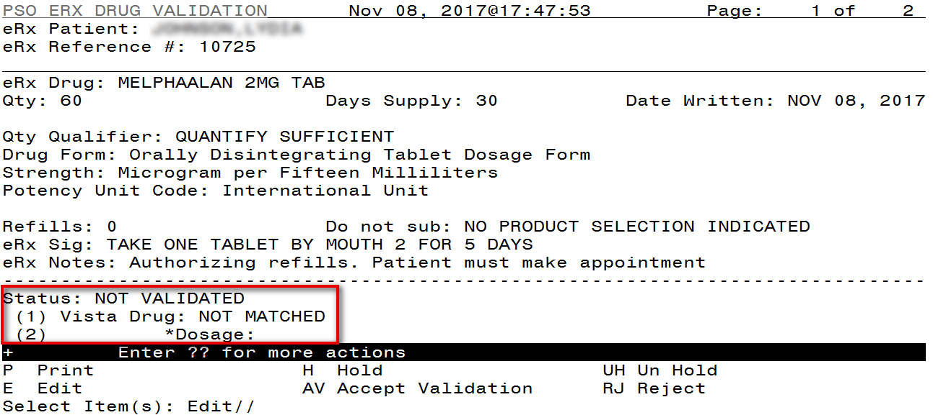

Figure 3‑31: Drug Validation Screen Display - VistA Drug Not Validated / Not Auto Matched

If a VistA match was found for the drug, the screen looks similar to the below figure. The Status field has “NOT VALIDATED”, with VistA Drug/SIG information displaying in the fields below.

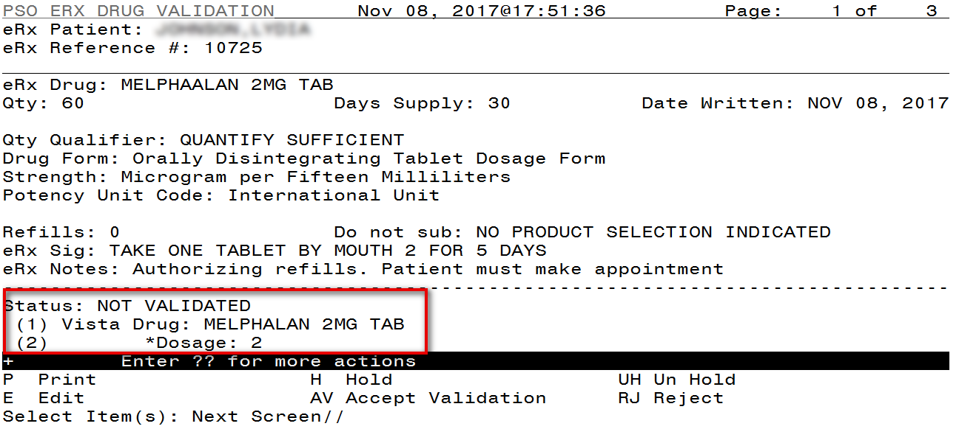

Figure 3‑32: Drug Validation Screen Display - VistA Drug Matched / Not Validated

#### Edit Drug/SIG

1. To edit the Drug/SIG information, use the <**E**> Edit action on the Drug Validation screen.
2. If the VistA Drug/SIG information has been linked for the eRx, the edit drug/SIG sequence prompts the user to select a field or select All fields:
   * Select Item (s): Quit// E Edit
   * Which fields (s) would you like to edit? (1-10) or ‘A’ 11: A//
3. Under eRx Holding Queue >> Validate Drug/SIG screen >> Edit, if a drug is already matched in the hub, that drug is displayed at the ‘select’ prompt. The user is still allowed to change the drug by entering the drug name.
4. Under eRx Holding Queue >> Validate Drug/SIG screen >> Edit, if a drug is not matched in the hub, at the ‘select’ prompt, it is blank wherein the user can enter the drug name.
5. When a Yes/No confirmation is asked for the selected drug, if the user hits enter or selects ‘No’, the control comes out of Edit mode back to VD screen.

**NOTE:** The eRx Drug/SIG information from the external provider displays throughout the edit Drug/SIG process as reference.

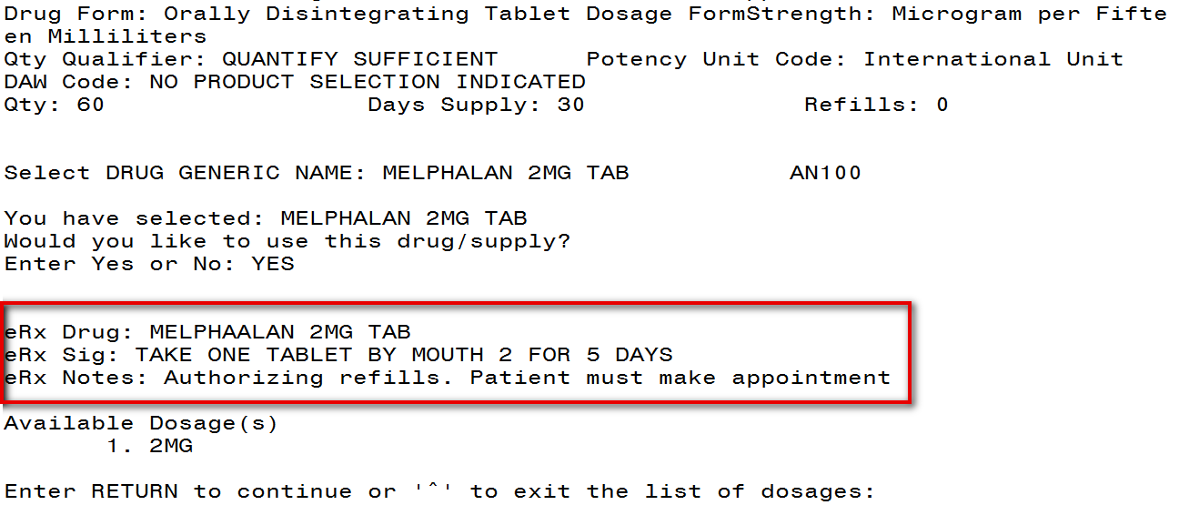

Figure 3‑33: eRx Display During Edit Drug / SIG

1. Next, enter the Dosage. Either enter a free text dose or enter a question mark <**?**> to view a list of available dosages. The system prompts the user to confirm the selected dosage.
2. Enter the Verb, Route, Schedule, and Limited Duration (optional).
3. Patient Instructions are default/consistent instructions that come from the Orderable Item. VA Patient Instructions are auto populated when either a drug is auto matched or manually matched or the drug’s Pharmacy Order Item has an entry for those instructions. If it is blank, enter VA Patient Instructions. Or if it needs to be edited, use the ‘Replace’ function. Even abbreviated Patient Instructions from Medication Instruction files are allowed, which expand upon saving. This field holds the patient instructions for an eRx. This field is transferred to the Pending Queue upon acceptance of an eRx.
4. Provider Comments are additional free text comments that the provider may enter. The VA Provider Comments field contains the eRx Notes from the external provider and can be edited by entering <**Replace**>. Even abbreviated Provider Comments from Medication Instruction files are allowed, which expand upon saving. This field is transferred to the Pending Queue upon acceptance of an eRx.
5. Enter Patient Status and edit the Patient Status as required. (Note that this field will be auto-populated for MbM, with the text “CHOICE”, whenever applicable).
6. Enter VistA Quantity, VistA Days Supply, and VistA Refills.
7. Enter Routing. Either <**M**> for Mail or <**W**> for Window.
8. The system displays the Default eRx Clinic setup by the site. If it is not configured, this field is blank. The user can select a clinic as required in either case.
9. Once all the drug/SIG fields have been edited and the drug/SIG sequence is complete, the edited information displays on the Drug Validation screen.
10. The next step is to accept the validation <**AV**>, which is described in the next section.
11. If you have to edit after this you can pick the fields:
    * Select Item (s): Quit// E Edit
    * Which fields (s) would you like to edit? (1-10) or ‘A’ 11: A//

**NOTE:** If the Default eRx Clinic is changed from the one that’s configured with the NPI Institution, of the receiving Pharmacy, the eRx may not show up in OERR when processed. Refer to the Inbound ePrescribing VistA Patch # PSO*7.0*467 Implementation Guide on the VA Documentation Library (VDL) for details on setting up the Default eRx Clinic for a site.

##### Additional Field-level Information:

* Potency Unit Code is displayed in the eRx Holding Queue >> Validate Drug/SIG screen >> Edit, along with the reference eRx information.
* eRx Quantity now displays up to 5 digits after the decimal in the eRx Holding Queue Summary Screen and VD >> Edit screen.
* VistA Quantity is displayed same as eRx Quantity if there are 2 digits after decimal places. If there are more than 2 digits after decimal places, VistA Quantity field is left blank so that the user can key in.
* eRx Days Supply now displays up to 999 in the eRx Holding Queue Summary Screen and VD >> Edit screen.
* VistA Days Supply is displayed same as eRx Days Supply if the value is under 366. If it is over 365, VistA Days Supply field is left blank so that the user can key in.
* eRx Refills now displays up to 99 in the eRx Holding Queue Summary Screen and VD >> Edit screen.
* VistA Refills is displayed same as eRx Refills if the value is under 12. If it is over 11, VistA Refills field is left blank so that the user can key in.
* Help text for VistA Quantity has been updated under eRx Holding Queue >> Validate Drug/SIG screen >> Edit.

#### Accept Drug/SIG Validation

Once the VistA Drug/SIG information has been edited and reviewed for accuracy, the next step is to accept the validation <**AV>** on the Drug Validation screen. The system prompts the user to confirm the validation. After entering <**Y>** Yes, a message displays that the drug validation has been updated.

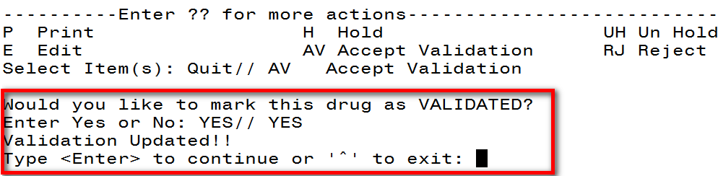

Figure 3‑34: Confirm Acceptance of Drug / SIG Validation

The Status changes to “VALIDATED” on the Drug Validation screen, along with the user who performed the validation and date/timestamp. “[v]” also displays to the right of the VistA Drug field on the Summary screen.

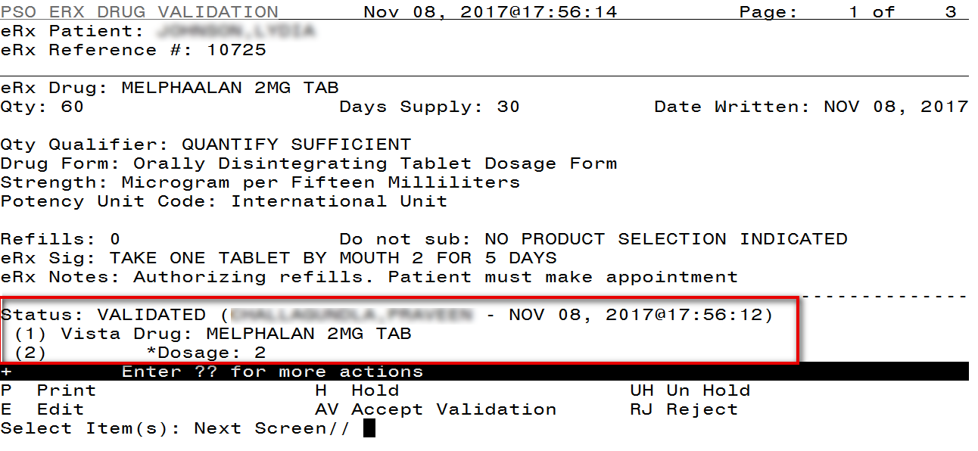

Figure 3‑35: Drug / SIG Validation Complete (Validate Drug / SIG Screen)

The modified VistA Drug/SIG information populates on the Drug/SIG Validation screen.

Press <**Enter**> to display Pages 2 and 3 of the Drug/SIG Validation screen.

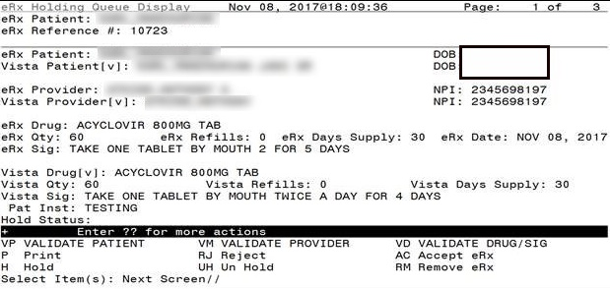

Figure 3‑36: Drug / SIG Validation Complete (Summary Screen)

#### Wait Status Flag ‘W’

When the user completes validating Patient, Provider and Drug/SIG for an eRx, the status of the prescription will change from I/In Process to W/Wait in the Holding Queue’s List View.

**NOTE:** eRx records in W/Wait status can be retrieved using the current SR/Search and SO/Sort actions, by selecting option 5. ERX STATUS.

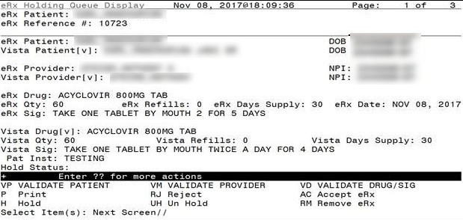

Figure 3‑37: eRx Holding Queue Summary Screen with Validations Complete

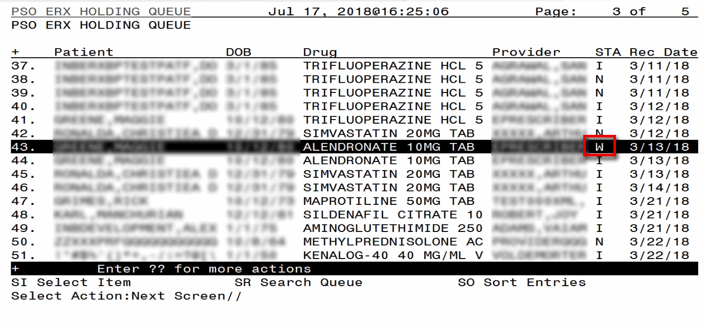

Figure 3‑38: eRx Holding Queue List View with eRx Record in ‘W’ Status

## Accepting eRxs in the eRx Holding Queue

The following conditions must be met, before an eRx can be accepted and transmitted to the Pending Queue for further processing:

1. The eRx cannot be on Hold. If the eRx is on Hold, the eRx status on the Holding Queue List has one of the Hold Status codes, and the Hold Status, Hold Reason, and the user who placed the eRx on hold is displayed on the Summary screen.
2. The eRx cannot have a status of ‘Rejected’ **RJ**, ‘Removed’ **RM**, or ‘Processed’ **PR**.
3. All validation steps, for patient, provider, and drug/SIG must be completed, including the **<AV>** Accept Validation action on the validate screens. For additional information on the validation steps, please refer to the Manual Validation section of this guide.

If a user attempts to accept an eRx where one or more of the conditions have not been met, an error message displays indicating that the eRx cannot be processed and the reason why.

Figure 3‑39: Accept eRx - Sample Validation Errors

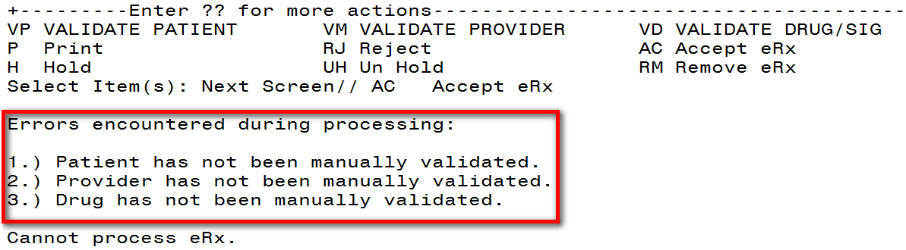

After all the above pre-conditions have been met, to Accept an eRx <**AC**> from the Summary screen, complete the following steps.

From the Summary Screen, type <**AC**> Accept eRx.

Figure 3‑40: Accept eRxs

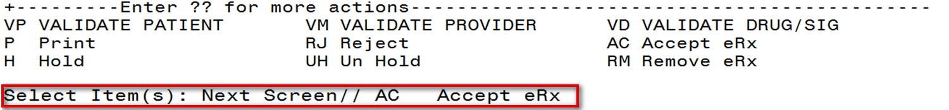

A message displays notifying the user that the eRx was sent to Pending Outpatient Orders for further processing.

Figure 3‑41: eRxs Sent to Pending Outpatient Orders

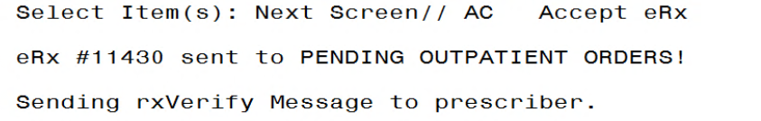

The user can then go to Complete Orders from OERR or Patient Prescription Processing to view the eRx information. Refer to the Complete Orders from OERR and Patient Prescription Processing section.

## Rejecting eRxs in the eRx Holding Queue

Reject is used to remove the eRx from the eRx Holding Queue and send an NCPDP message back to the originating EHR system indicating that eRx has been rejected. Reject must be accompanied by a reject code/reason. To reject an eRx, complete the following steps:

1. From the Summary screen, type <**RJ>** Reject.
2. Enter <**Y>** Yes to confirm the reject.
3. Enter a reason for the rejection. The following reasons are available:

203 PTT01 Patient not eligible

204 PTT02 Cannot resolve patient

205 PVD01 Provider not eligible

206 PVD02 Cannot resolve provider

207 DRU01 Not eligible for refills

208 DRU02 Non-formulary drug

209 DRU03 Duplicate prescription found for this patient

210 DRU04 Invalid quantity

211 DRU05 Duplicate therapeutic class

212 DRU06 Controlled substances are disallowed

213 ERR01 Multiple errors, please contact the pharmacy

214 ERR02 Incorrect pharmacy

215 ERR03 Issues with prescription, please contact the pharmacy

1. Type additional comments as to why the eRx is being rejected and press <**Enter**>. These comments are optional.

Figure 3‑42: Rejecting an eRx

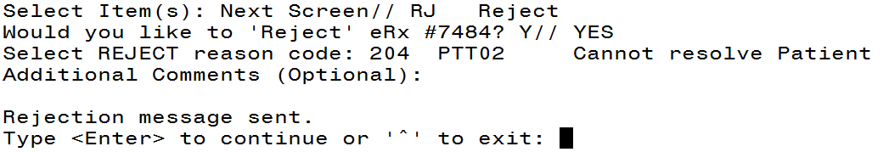

Once the eRx is rejected, the details of the reject message will be available in the IEP Processing Hub as reference. Refer to the figure below.

Figure 3‑43: Reject Message in Processing Hub

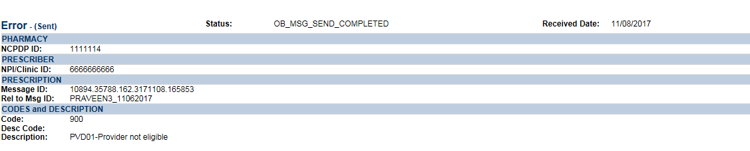

## Printing in the eRx Holding Queue

From the Summary screen and from any of the validate screens, the <**P>** Print action is available to print the eRx.

1. Enter <**P>** Print.
2. Enter the Device (local or network printer) and press <**Enter**>.

The print display of the eRx, refer to the figure below, prints to the selected printer.

Figure 3‑44: Print Display of eRx

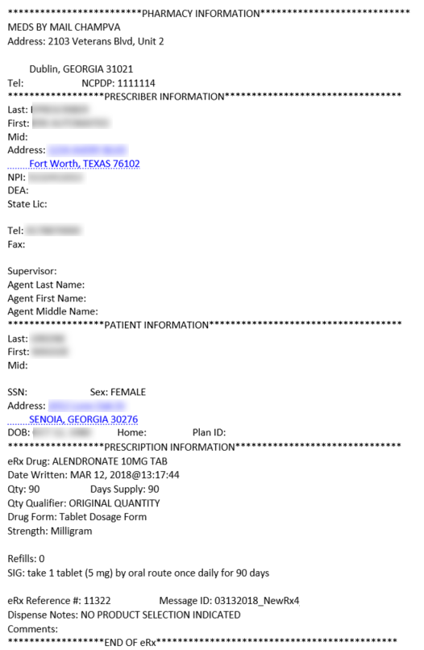

## Placing eRxs on Hold in the eRx Holding Queue

An eRx can be placed on hold for various reasons indicating that there is an issue with the eRx.

**NOTE:** If an eRx is placed on hold, the user can continue with all the available validate actions; however, the eRx cannot be accepted if an eRx is on hold.

1. To place an eRx on hold, type <**H>** Hold from the Summary screen or any of the validate screens.
2. Enter a hold reason from the available reasons. The following reasons are available:

118 HPT PATIENT NOT FOUND

119 HPD PROVIDER NOT FOUND

120 HNF NON-FORMULARY DRUG THAT NEEDS APPROVAL

121 HSO INSUFFICIENT STOCK

122 HDI DRUG-DRUG INTERACTION

123 HAD ADVERSE DRUG INTERACTION

124 HBA BAD ADDRESS

125 HPC PROVIDER CONTACTED

126 HPA PRIOR APPROVAL NEEDED

127 HOR OTHER REASON

128 HPP PATIENT CONTACTED

129 HPR HOLD DUE TO PATIENT REQUEST

130 HQY QUANTITY OR REFILL ISSUE

1. To view the available hold reasons, enter a double question mark <**??>** at the “Select HOLD reason code” prompt, refer to the figure below. The available hold reasons display.

Figure 3‑45: Hold eRx

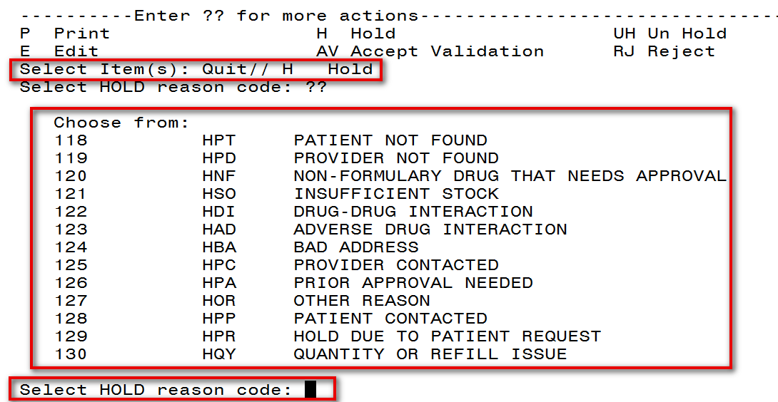

1. Enter the reason code at the “Select HOLD Reason code:” prompt and press <**Enter**>.
2. A prompt displays asking for additional comments on the reason for the hold. These comments are optional. Either press <**Enter**> to complete the hold process or add comments and then press <**Enter**>.

Figure 3‑46: Select Hold Reason Code



The Hold Status, Hold Reason, and the user placing the eRx on hold display below the VistA Drug section on the Summary screen.

Figure 3‑47: Hold Status and Reason

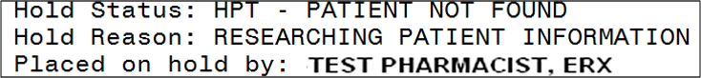

The hold status also displays in the “Status” column (STA) on the Holding Queue List screen.

Figure 3‑48: Hold Status in Status Column

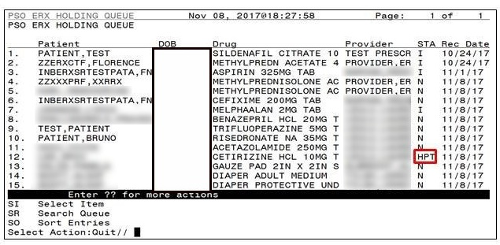

### Un Hold eRx in the eRx Holding Queue

eRxs may be removed from a hold by typing <**UH>** Un Hold. Users who see the Un Hold function in parentheses ( ) are not able to remove an eRx from a hold.

Figure 3‑49: Un Hold eRx

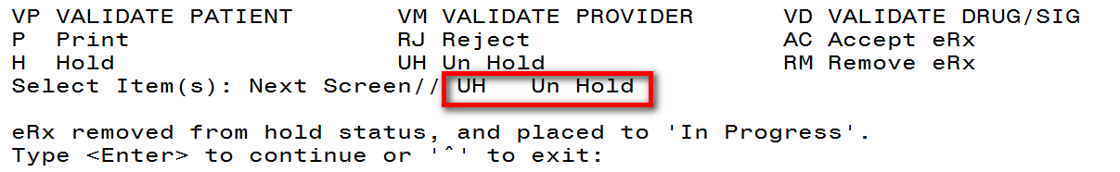

## Removing eRxs in the eRx Holding Queue

An eRx can be removed from the Holding Queue without sending a message back to the originating external provider. Sample scenarios, include, but are not limited to, the patient requested that the eRx not be filled, or the user has been unable to contact the provider or patient for a significant amount of time.

To remove an eRx from the Holding Queue:

1. From the Summary screen, type <**RM>** Remove.
2. Enter a reason for the eRx removal. The following removal reasons are available:

216 REM01 Drug out of stock or on backorder and unavailable for processing

217 REM02 Patient was not able to pick up

218 REM03 Prescription canceled by provider

219 REM04 Prescription processed manually

220 REM05 Provider will cancel this eRx and submit another

221 REM06 Unable to mail prescription and patient unable to pick up

222 REM07 Unable to contact patient

223 REM08 Unable to contact provider

224 REM91 Undefined system error

225 REM92 Other

1. Type additional comments as to why the eRx is being removed and press <Enter>. These comments are optional.

Once the eRx is removed, the status changes to “RM” and it no longer displays in the default Holding Queue list; however, the eRx can be accessed via the search action from the main Holding Queue List screen using one or more of the search criteria. Refer to Searching eRxs.

Figure 3‑50: Removing an eRx

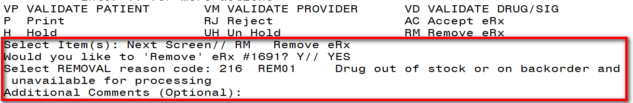

**NOTE:** If the Remove eRx function is in parentheses ( ), the user will not be able to remove an eR**x**. If the action is still attempted, the user receives a message that the action is not available.

## Searching and Sorting in the eRx Holding Queue

Users can search and sort eRxs in the Holding Queue. Searching and sorting eRxs is described in the following sections.

### Searching eRxs

Searching and filtering of eRxs is available by typing <**SR>** Search Queue at the “Select Action” prompt. The Search Queue screen displays. Users can search using one or more of the following search criteria:

1. PATIENT NAME
2. DATE OF BIRTH
3. RECEIVED DATE RANGE
4. PROVIDER NAME
5. ERX STATUS
6. DRUG NAME

Figure 3‑51: Search Queue Actions

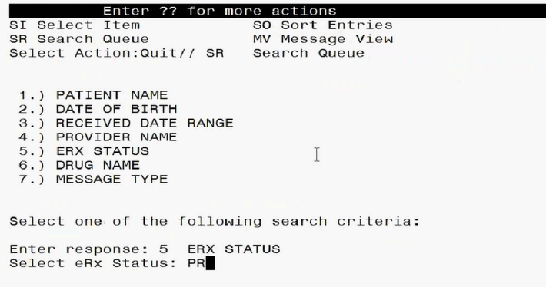

The default search displays all eRxs except **RM** Removed, **RJ** Rejected, or **PR** Processed items (unless the user searches by ERX STATUS and specifically selects one of these statuses. The display contains all eRxs satisfying the search criteria. The list is refreshed depending on the action performed. After an action is performed, the user can return to the original filtered list.

#### Search eRx – Patient Name

Users can search by patient name. A search initiated with a partial patient name may return multiple patient names, from which one patient can be selected. Selecting a patient displays the eRxs for that patient.

To search by patient name:

1. From the eRx Holding Queue List screen, type <**SR**> Search Queue.
2. From the Search Queue, type <**1**> or PATIENT NAME.

Figure 3‑52: Search Criteria - Patient Name

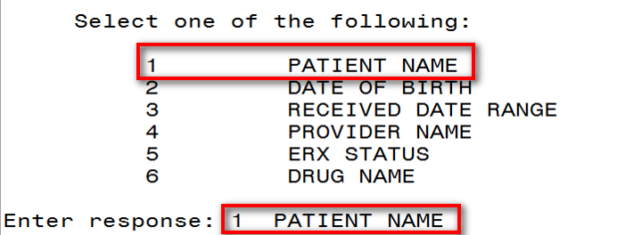

1. Type the full or partial name of the patient press <**Enter**>. If multiple patients exist for the search criteria entered, select the correct patient from the list provided.

Figure 3‑53: Patient Name Search

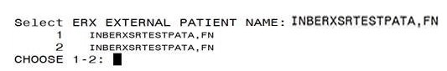

1. A message displays indicating that the user can enter additional search criteria or press <**Enter**> to continue with the current search.

The search results display. To execute another search, enter **^** or **Quit** to exit the current search and return to the original Holding Queue list. The **SR** Search Queue action is in parentheses, indicating that the user must exit the current search to execute a new search.

Figure 3‑54: Search eRx by Patient Name Results

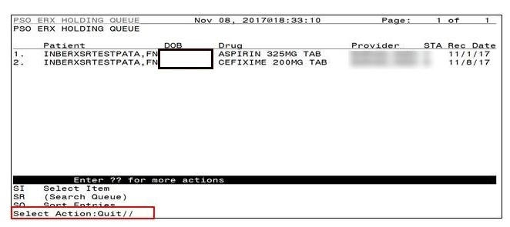

#### Search eRx – Date of Birth

To search by patient’s date of birth:

1. From the eRx Holding Queue List screen, type <**SR**> Search Queue.
2. From the Search Queue Type <**2>** or DATE OF BIRTH.
3. Enter the date of birth and press <**Enter**>.
4. A message displays indicating that the user can enter additional search criteria or press <**Enter**> to continue with the current search.

Figure 3‑55: Search Criteria - Date of Birth

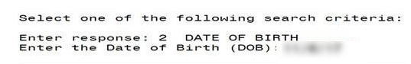

The search results in the following display:

Figure 3‑56: Search eRx by Date of Birth Results

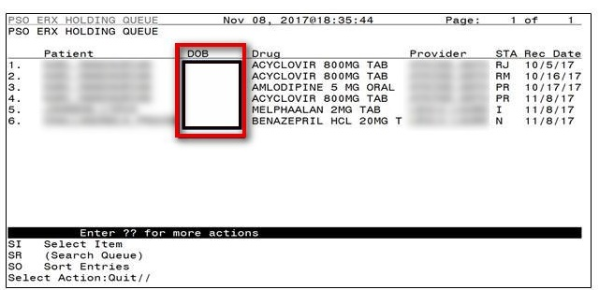

#### Search eRx – Received Date Range

To search for an eRx by a received date range:

1. From the eRx Holding Queue List screen, type <**SR**> Search Queue.
2. Type <**3>** or RECEIVED DATE RANGE.

Figure 3‑57: Search Criteria - Received Date Range

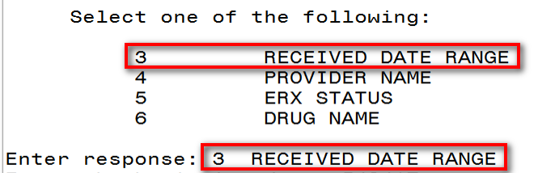

1. Enter the beginning date and press <**Enter**>.
2. Enter the ending date and press <**Enter**>.
3. A message displays indicating that the user can enter additional search criteria or press <**Enter**> to continue with the current search.

Figure 3‑58: Enter Beginning and Ending Date

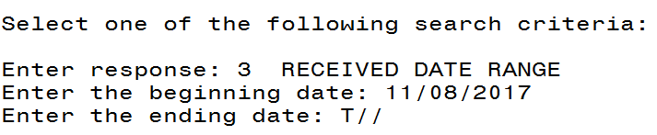

The search results display.

Figure 3‑59: Search eRx by Received Date Range

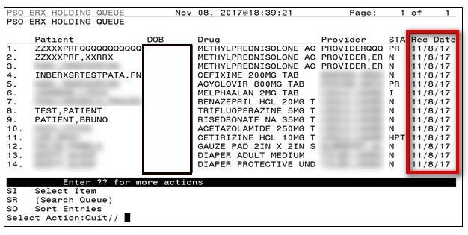

#### Search eRx – Provider Name

To search for an eRx by a provider:

1. From the eRx Holding Queue List screen, type <**SR**> Search Queue.
2. Type <**4>** or PROVIDER NAME.

Figure 3‑60: Search Criteria - Provider Name

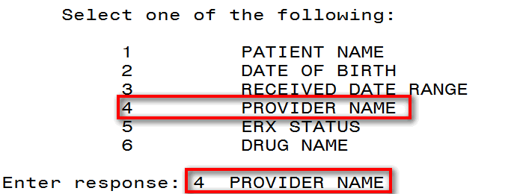

1. Type the provider’s name and press <**Enter**>.

Figure 3‑61: Enter Provider Name

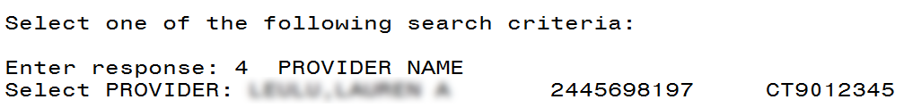

The search results display:

Figure 3‑62: Search eRx by Provider

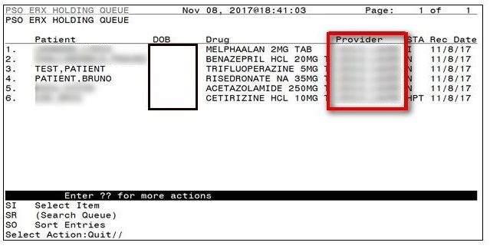

#### Search eRx – ERX Status

To search for an eRx by Status:

1. From the eRx Holding Queue List screen, type <**SR**> Search Queue.
2. Type <**5>** orERX STATUS.
3. Enter the eR**x** status and press <**Ente**r>.

Figure 3‑63: Search Criteria - eRx Status



The search results display.

Figure 3‑64: Search by eRx Status

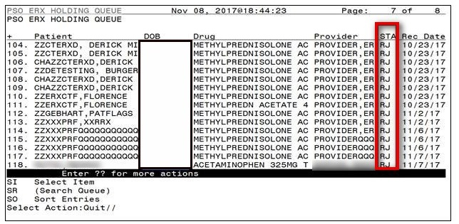

For more information on the available statuses in the Holding Queue, refer to Appendix A Holding Queue Status Codes & Descriptions.

#### Search eRx – Drug Name

To search for an eRx by Drug Name:

1. From the eRx Holding Queue List screen, type <**SR**> Search Queue.
2. Type <**6>** or DRUG NAME.
3. Type the name or partial name of the incoming eRx drug and press <**Enter**>.

Figure 3‑65: Search Criteria - Drug Name

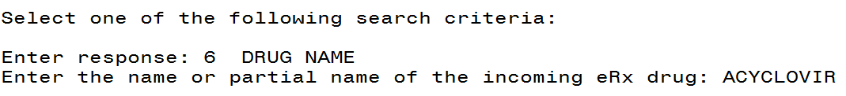

The search results display:

Figure 3‑66: Search eRx by Drug Name

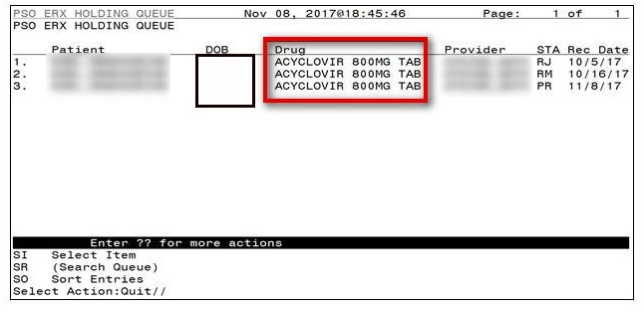

### Sorting eRxs

VA users can sort eRxs in the Holding Queue List. Sort parameters are retained at the user level when reentering the original list during the same session (i.e., when performing an action on an eRx and then reentering the eRx list). The default sort order of the Holding Queue list is the following:

1. Date Received - Oldest date to Newest date
2. Secondary sort by Patient Name

Additional sorting of eRxs is available by typing <**SO**> Sort Entries.

Figure 3‑67: Sort Entries Action

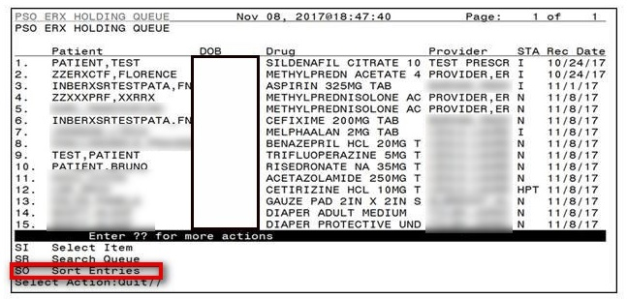

eRxs can be sorted by only one criterion at a time. The sort criteria include:

* **Patient Name**: Sorted by Patient in ascending order (A-Z), and within Patient by Received Date with most recent first, and then by Provider in ascending order (A-Z)
* **Date of Birth**: By DOB, newest Received Date first, Patient Name ascending
* **Received Date Range:** Sorted by Received Date with most recent first and within Received Date by Patient in ascending order (A-Z), and then by Provider in ascending order (A-Z)
* **Provider Name**: Sorted by Provider in ascending order (A-Z), and within Provider by Received Date with oldest first, and then by Patient in ascending order (A-Z)
* **eRx Status:** Patient Name ascending, newest Received Date first
* **Drug Name:** Patient Name ascending, newest Received Date first

#### Sort eRx – Patient Name

To sort by patient:

1. From the eRx Holding Queue List screen, type <**SO**> Sort Entries.
2. Type <**1**> or Patient Name.

Figure 3‑68: Sort by Patient Name

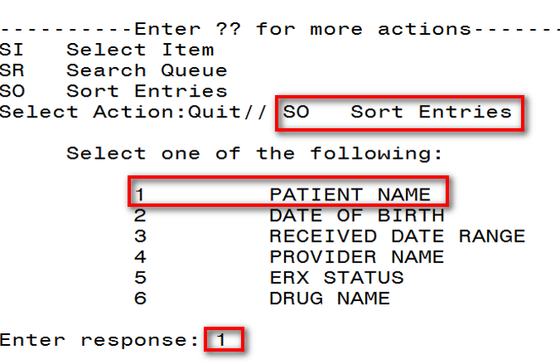

1. The sorted entries display Sorted by Patient in ascending order (A-Z), and within Patient by Received Date Range with most recent first, and then by Provider in ascending order (A-Z).

#### Sort eRx – Date of Birth

To sort by Date of Birth:

1. From the eRx Holding Queue List screen, type <**SO**> Sort Entries.
2. Type <**2**> or Date of Birth.
3. The entries display by DOB, newest Received Date first, Patient Name ascending.

#### Sort eRx – Received Date Range

To sort eRxs by received date (most recent date displays at top of sort results):

1. From the eRx Holding Queue List screen, type <**SO>** Sort Entries.
2. Type <**3**> or Received Date Range.

Figure 3‑69: Sort by Received Date Range

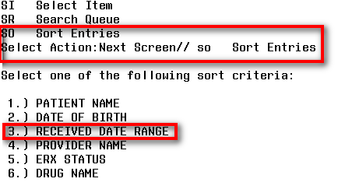

1. The entries sort by Received Date with most recent first and within Received Date by Patient in ascending order (A-Z), and then by Provider in ascending order (A-Z).

#### Sort eRx – Provider Name

To sort eRxs by provider name:

1. From the eRx Holding Queue List screen, type <**SO**> Sort Entries.
2. Type <**4**> or Provider Name.

Figure 3‑70: Sort Criteria - Sort by Provider

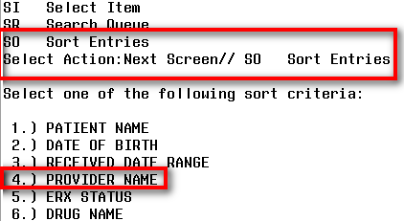

1. The entries sort by Provider in ascending order (A-Z), and within Provider by Received Date with oldest first, and then by Patient in ascending order (A-Z).

#### Sort eRx – eRX Status

To sort eRxs by eRx Status:

1. From the eRx Holding Queue List screen, type <**SO**> Sort Entries.
2. Type <**5**> or ERX Status.
3. The entries sort by Patient Name ascending, newest Received Date first.

#### Sort eRx – Drug Name

To sort eRxs by Drug Name:

1. From the eRx Holding Queue List screen, type <**SO**> Sort Entries.
2. Type <**6**> or Drug Name.
3. The entries sort by Patient Name ascending, newest Received Date first.

## Complete Orders from OERR and Patient Prescription Processing

Following all the validation steps for patient, provider, and Drug/SIG, and after the eRx has been accepted, the eRx advances to Pending Outpatient Orders file for further processing. The eRx is further finished using either Complete Orders from OERR or Patient Prescription Processing. The eRx information displays at the top of the screen under the Secondary header, as shown in the figure below in both Complete Orders from OERR and Patient Prescription Processing. The hidden Option EP is provided in Outpatient to print the eRx (see figure below).

Figure 3‑71: Hidden Option EP / Print Display of eRx

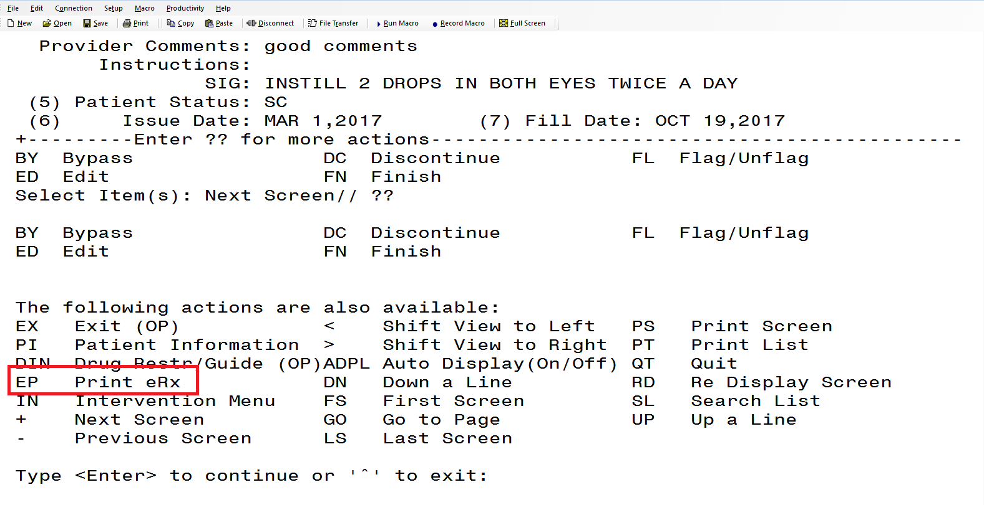

The eRx information can be edited and either finished to process further for dispensing or discontinued as needed, such as in case of duplicate orders since it is not filtered in the eRx Holding Queue.

Figure 3‑72: eRx Display in Pending Queue - Page 1

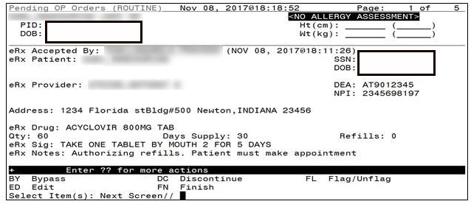

Please refer to the user manuals available on the VA Documentation Library (VDL) for information on Complete Orders from OERR and Patient Prescription Processing.

Press <**Enter**> to view Pages 2 and 5 of the order in the Pending Queue.

Figure 3‑73: eRx Order in Pending Queue – Page 2

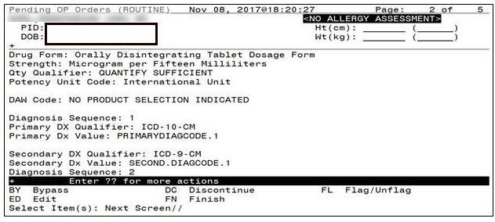

Figure 3‑74: eRx Order in Pending Queue - Page 3

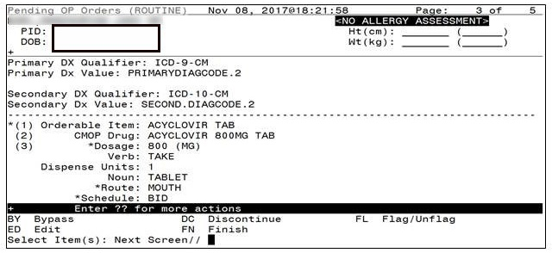

Figure 3‑75: eRx Order in Pending Queue - Page 4

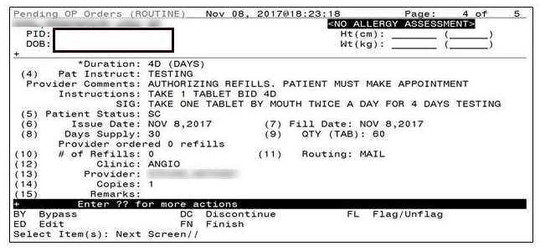

Figure 3‑76: eRx Order in Pending Queue - Page 5

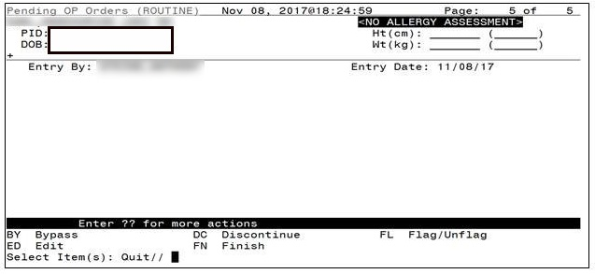

**NOTE:** The issue date is the same as Effective Date if sent by the Provider on the eRx, if not, it is the same as the Written Date as sent on the eRx.

## Help Desk

For issues related to the VistA OP eRx Holding Queue that cannot be resolved by this manual or the site administrator, please contact the National Service Desk at 855-NSD-HELP (673-4357) and reference “Inbound eRx”.

1. Holding Queue Status Codes & Descriptions

Table 7: Holding Queue Status Codes & Descriptions

| Status Type | VistA IEN Number | Status Code | Description |
| --- | --- | --- | --- |
| New |  | N | Status of the eRx when it first arrives in the Holding Queue and has not been acted upon in anyway. |
| In Process |  | I | Status of the eRx when a user has taken an action on the eRx in the Holding Queue, including via the automatic patient or provider validation process. |
| Wait |  | W | Status of the eRx when a user has completed all 3 validations (Accept Validation/AV), on Patient, Provider and Drug/SIG, and has not yet completed the Accept (AC) action to process the eRx into the Pending Queue. |
| Hold |  |  | Refer to the various hold statuses and descriptions below. |
|  | 118 | HPT | Patient not found |
|  | 119 | HPD | Provider not found |
|  | 120 | HNF | Non-Formulary drug that needs approval |
|  | 121 | HSO | Insufficient stock |
|  | 122 | HDI | Drug interaction |
|  | 123 | HAD | Adverse drug interaction |
|  | 124 | HBA | Bad address |
|  | 125 | HPC | Provider contacted |
|  | 126 | HPA | Prior approval needed |
|  | 127 | HOR | Other reason |
|  | 128 | HPP | Patient contacted |
|  | 129 | HPR | Hold due to patient request |
|  | 130 | HQY | Quantity or refill issue |
| Reject |  | RJ | Status of the eRx when it has been rejected by a user. A message is sent back to the external provider indicating the eRx was rejected and the reason for rejection. Refer to the various reject reasons below. |
|  | 203 | PTT01 | Patient not eligible |
|  | 204 | PTT02 | Cannot resolve patient |
|  | 205 | PVD01 | Provider not eligible |
|  | 206 | PVD02 | Cannot resolve provider |
|  | 207 | DRU01 | Not eligible for refills |
|  | 208 | DRU02 | Non-formulary drug |
|  | 209 | DRU03 | Duplicate prescription found for this patient |
|  | 210 | DRU04 | Invalid quantity |
|  | 211 | DRU05 | Duplicate therapeutic class |
|  | 212 | DRU06 | Controlled substances are disallowed |
|  | 213 | ERR01 | Multiple errors, please contact the pharmacy |
|  | 214 | ERR02 | Incorrect pharmacy |
|  | 215 | ERR03 | Issues with prescription, please contact the pharmacy |
| Remove |  | RM | Status of the eRx when it has been removed by a user. (**Note** that a message is NOT sent back to the external provider when an eRx is removed. Refer to the various remove reasons below.) |
|  | 216 | REM01 | Drug out of stock or on backorder and unavailable for processing |
|  | 217 | REM02 | Patient was not able to pick up |
|  | 218 | REM03 | Prescription canceled by provider |
|  | 219 | REM04 | Prescription processed manually |
|  | 220 | REM05 | Provider will cancel this eRx and submit another |
|  | 221 | REM06 | Unable to mail prescription and patient unable to pick up |
|  | 222 | REM07 | Unable to contact patient |
|  | 223 | REM08 | Unable to contact provider |
|  | 224 | REM91 | Undefined system error |
|  | 225 | REM92 | Other |

1. NCPDP Error Codes

This appendix outlines common NCPD error codes and their descriptions, which will be visible in the Detail View of a message in the IEP Web-based application.

Table 8: NCPDP Error Codes

| Element Name | M/O | Datatype | Possible Values | Description |
| --- | --- | --- | --- | --- |
| Code | M | String | 600|601|602|900 | 6ØØ Communication problem - try again later. 6Ø1 Receiver unable to process. 6Ø2 Receiver system error. 9ØØ Transaction rejected. |
| Description Code | O | String | 001|002|003 | ØØ1 Sender ID not on file. ØØ2 Receiver ID not on file. ØØ3 Invalid password for sender. ØØ4 Invalid password for receiver. ØØ5 No password on file for sender. ØØ6 No password on file for receiver. ØØ7 Internal processing error has occurred. ØØ8 Request timed out before response could be received. ØØ9 Required segment UIB is missing. Ø1Ø Required segment UIH is missing. Ø11 Required segment UIT is missing Ø12 Required segment UIZ is missing Ø13 Unknown segment has been encountered, etc. |
| Description | O | an (70) | Free text |  |